**2019-2020 Kenai Beach Bacteria Monitoring Report**

FY20-21 Final Report

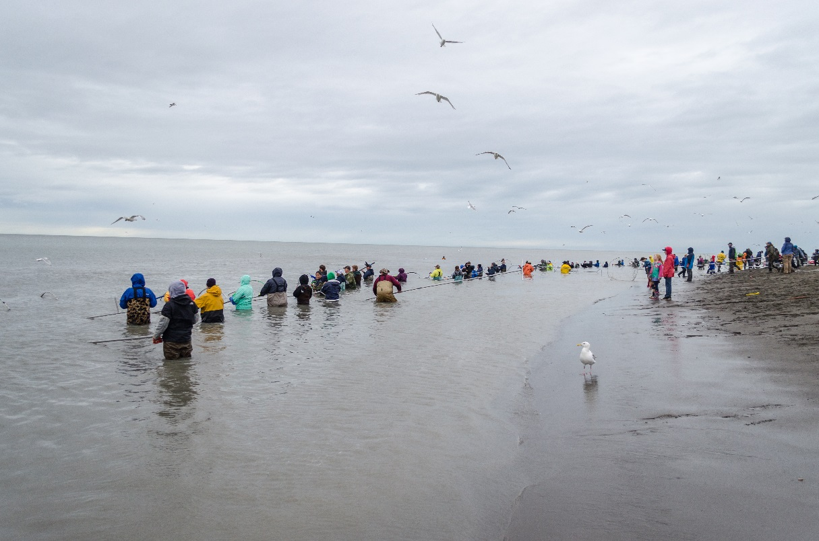

Prepared for the Alaska Department of Environmental Conservation

Grant: ACWA-19-B11

***The Kenai Watershed Forum is dedicated to successfully identifying and addressing the needs of the region by providing high quality education, restoration, and research programs.***



***“Working together for healthy watersheds on the Kenai Peninsula”***

**Draft report: January 15, 2021**

**Prepared by:**

Benjamin Meyer

Environmental Scientist

44129 Sterling Highway

Soldotna, Alaska 99669

(907) 260-5449

www.kenaiwatershed.org

Table of Contents

**List of Tables** iii

**List of Figures** iii

**Executive summary** 1

**Introduction** 2

**Methods** 4

**Monitoring locations** 4

**Sampling design** 6

**2019-2020: Microbial source tracking** 7

**Quality assurance and quality control** 7

**Water quality standards** 8

**Public outreach** 10

**Results** 10

**Results summary** 10

**Bacteria concentrations monitoring 2019 - 2020** 11

**Enterococci** 11

**Fecal Coliform** 13

**2019 - 2020 Microbial Source Tracking Data** 15

**Discussion** 16

**2019-2020 Kenai beach bacteria monitoring** 16

**2019-2020 Microbial source tracking** 20

**Conclusions and recommendations** 20

**Data availability** 21

**References** 22

**Appendix A: Site Photographs** 24

**Appendix B: Press Releases** 29

**Appendix C: Chain-of-Custody** 34

**Appendix D: EPA Marine Beach Sanitary Survey** 35

**Appendix E: Samples Values and Exceedances** 36

**Appendix F: Microbial Source Tracing Data** 45

# **List of Tables**

Table 1. 2019-2020 Kenai beach bacteria monitoring site locations and descriptions. 4

Table 2. 2019-2020 ADEC water quality standards for fecal coliform and enterococci in marine waters 9

Table 3. Mean percent difference between replicate sample values. 11

Table 4: Summary values for 30-day geometric mean concentrations. 13

Table 5: Microbial source tracing data. 45

# **List of Figures**

Figure 1. Kenai River and Kenai Beach dipnet personal use fishery map 2

Figure 2. 2019-2020 Kenai River beach sampling sites. 5

Figure 3: Duration of criteria exceedance type for each site. 12

Figure 4: 30-day geometric mean values. 14

Figure 5: Results from microbial source tracing (MST) analyses. 15

Figure 6: Percent of sample days where bacteria sample values exceeded criteria thresholds. 17

Figure 7: Growth of the Kenai River personal use fishery. 18

Figure 8: 2017 – 2020 late run sockeye salmon counts on the Kenai River 19

# **Acronyms**

**ADEC** – Alaska Department of Environmental Conservation

**ADF&G** – Alaska Department of Fish and Game

**BMP** – Best Management Practices

**CoK** – City of Kenai

**EPA** – Environmental Protection Agency

**KWF** – Kenai Watershed Forum

**MST** – Microbial Source Tracking

**PUF** – Personal Use Fishery

# **Executive summary**

Under contracts with the City of Kenai (CoK), the Kenai Watershed Forum (KWF) has been working with the Alaska Department of Environmental Conservation (ADEC) for several summers in an ongoing initiative to monitor bacteria concentrations at public beaches and within the lower six miles of the Kenai River in Kenai, Alaska. Bacteria monitored included fecal coliform and enterococci, both of which are found in the excrement of warm-blooded animals such as gulls. Gulls are attracted to Kenai beaches by fish carcasses produced during the personal use dipnet fishery (PUF). In order to establish a baseline for bacteria, Kenai Watershed Forum began monitoring fecal coliform and enterococci concentrations from 2010-2014 at sites in the lower six miles of the Kenai River and along its beaches at the mouth. In 2015, best management practices (BMPs) were implemented by the City of Kenai, which included clearing fish carcasses from the beaches at night during the dipnet personal use fishery to reduce the number of gulls present during the day. To assess changes in bacteria concentrations post-BMP implementation, Kenai Watershed Forum conducted monitoring from 2018-2020 at sites located at the North and South Kenai Beaches; Warren Ames Memorial Bridge; and upstream and downstream of the gull rookery. Microbial source tracking (MST) was also conducted prior to and during the personal use dipnet fishery in order to identify sources of these bacteria from 2019-2020. This document summarizes results from the 2019-2020 monitoring seasons and makes recommendations for the continuation of successful beach monitoring efforts in conjunction with the use of the Environmental Protection Agency (EPA) Virtual Beach Model.

# **Introduction**

The Kenai River is a glacially-fed river located on Alaska’s Kenai Peninsula that begins at the outlet of Kenai Lake and flows into Cook Inlet, a branch of the Gulf of Alaska. Known internationally for its prolific fisheries, the Kenai River supports the Cook Inlet’s largest population of wild Pacific Salmon. Each summer, thousands of recreationists participate in the Kenai River sport fishing season, which includes an Alaska resident-only personal use dipnet fishery (PUF) during much of July.

Since 1996, the Alaska Department of Fish and Game (ADFG) has managed the dipnet personal use fishery for Alaska residents under the Kenai River Late-Run Sockeye Salmon Management Plan (5 AAC 21.350, 2020). The dipnet personal use fishery is generally open from July 10th to July 31st starting from the Warren Ames Memorial Bridge between miles five and six of the Kenai River, to the mouth of the river, where the boundary extends along the North and South Kenai Beaches (Figure 1).While providing ample fishing and recreational opportunities for state resident recreationists, the dipnet personal use fishery also bolsters the local economy and is highly valued by many throughout the state. However, the fishery annually results in accumulation of fish carcass waste along the North and South Kenai beaches from fish cleaned on site by users.

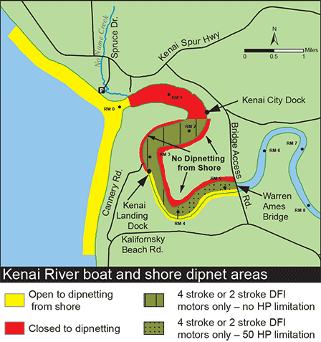

Figure 1. Kenai River and Kenai Beach dipnet personal use

fishery access locations (Alaska Department of Fish and Game, 2018).

Common practice of recreationists within the dipnet personal use fishery involves processing fish and discarding the waste along the beaches or within nearshore ocean water. It is also common to store freshly-caught fish on the beaches before processing them. The fish and resulting waste exposed along the beaches draws thousands of gulls from an established upstream gull rookery to the area each day to feed. The excrement from these gulls carries bacteria including fecal coliform bacteria and enterococci, which affect water quality along the North and South Kenai Beaches. When in exceedance of Alaska Department of Environmental Conservation water quality standards, these bacteria can be indicative of water containing concentrations of other bacteria that could induce illness.

Monitoring for fecal coliform and enterococci bacteria was initiated in 2010 in Kenai, Alaska. Throughout the 2010-2014 monitoring seasons, bacteria concentrations were found to periodically exceed the state standards throughout this timeframe and, in response, the City of Kenai implemented best management practices (BMPs) in 2014. These required the nightly clearing of fish carcasses from North and South Kenai Beaches and installing portable toilets during the personal use dipnet fishery season. Such practices were executed with the goal of reducing sources of bacteria, thereby minimizing the exposure of recreationists and fishermen.

Following three years of BMP implementation, Kenai Watershed Forum was contracted through the City of Kenai to work with ADEC to sample for fecal coliform bacteria and enterococci concentrations throughout the summers of 2018-2020. The sampling objective was to monitor changes in these bacteria concentrations post-BMP implementation. Kenai Watershed Forum conducted weekly bacteria sampling from May-September 2019 and 2020 at the North and South Kenai Beaches, two sites near the upriver gull rookery, and near the Warren Ames Memorial Bridge (Figure 2).

In order to examine the degree to which various potential sources of terrestrial feces (gull, human, and dog), sampling for microbial source tracking (MST) (Green et al., 2019) analyses were also conducted in 2019 and 2020 before and during the personal use dipnet fishery to identify and quantify fecal sources in the system.

Throughout monitoring efforts, water quality exceedances of both fecal coliform and enterococci were identified, particularly at the North and South Kenai Beach sampling locations. In response, Kenai Watershed Forum collaborated with the City of Kenai and Alaska Department of Environmental Conservation to conduct public outreach and education centered around the potential health risks and preventative measures the public could take in order to avoid contact with contaminated water.

This report focuses on the 2019 – 2020 monitoring seasons. Results from the 2018 field season are found in a previously published report (Harings, 2019).

# **Methods**

Prior to monitoring each sampling season, the ADEC BEACH Water Quality Monitoring and Pathogen Detection Quality Assurance Project Plan (QAPP) was revised for sampling at five predetermined sites within the lower reaches of the Kenai River as well as along the North and South Kenai Beaches. Kenai Watershed Forum personnel were trained in sampling techniques using the methods outlined in the QAPP and sampling was supervised by senior personnel throughout the summer for consistency and technique. ADEC also joined for one sampling event each season for quality assurance.

## **Monitoring locations**

All five monitoring locations (Table 1 and Figure 2) are located throughout the lower six miles of the Kenai River and along the North and South Kenai Beaches at the Kenai River outlet along Cook Inlet. During peak recreation and fishing periods in July and August, this area experiences high pressure from both commercial and personal-use power boats as well as bank fisherman during the dipnet personal use fishery from July 10th -July 31st. The most upstream site, Warren Ames Memorial Bridge, receives little pressure from fishermen and was chosen as a monitoring site for background concentrations of fecal coliform and enterococci bacteria. Further downstream near the Kenai River outlet is a large gull rookery located on river left that, at times, plays host to thousands of gulls. The North and South Kenai Beaches located near the Kenai River outlet draw thousands of dipnetters during the personal use fishery season. Sampling site photographs can be found in Appendix A: Site Photographs.

Table 1. 2019-2020 Kenai beach bacteria monitoring site locations and descriptions.



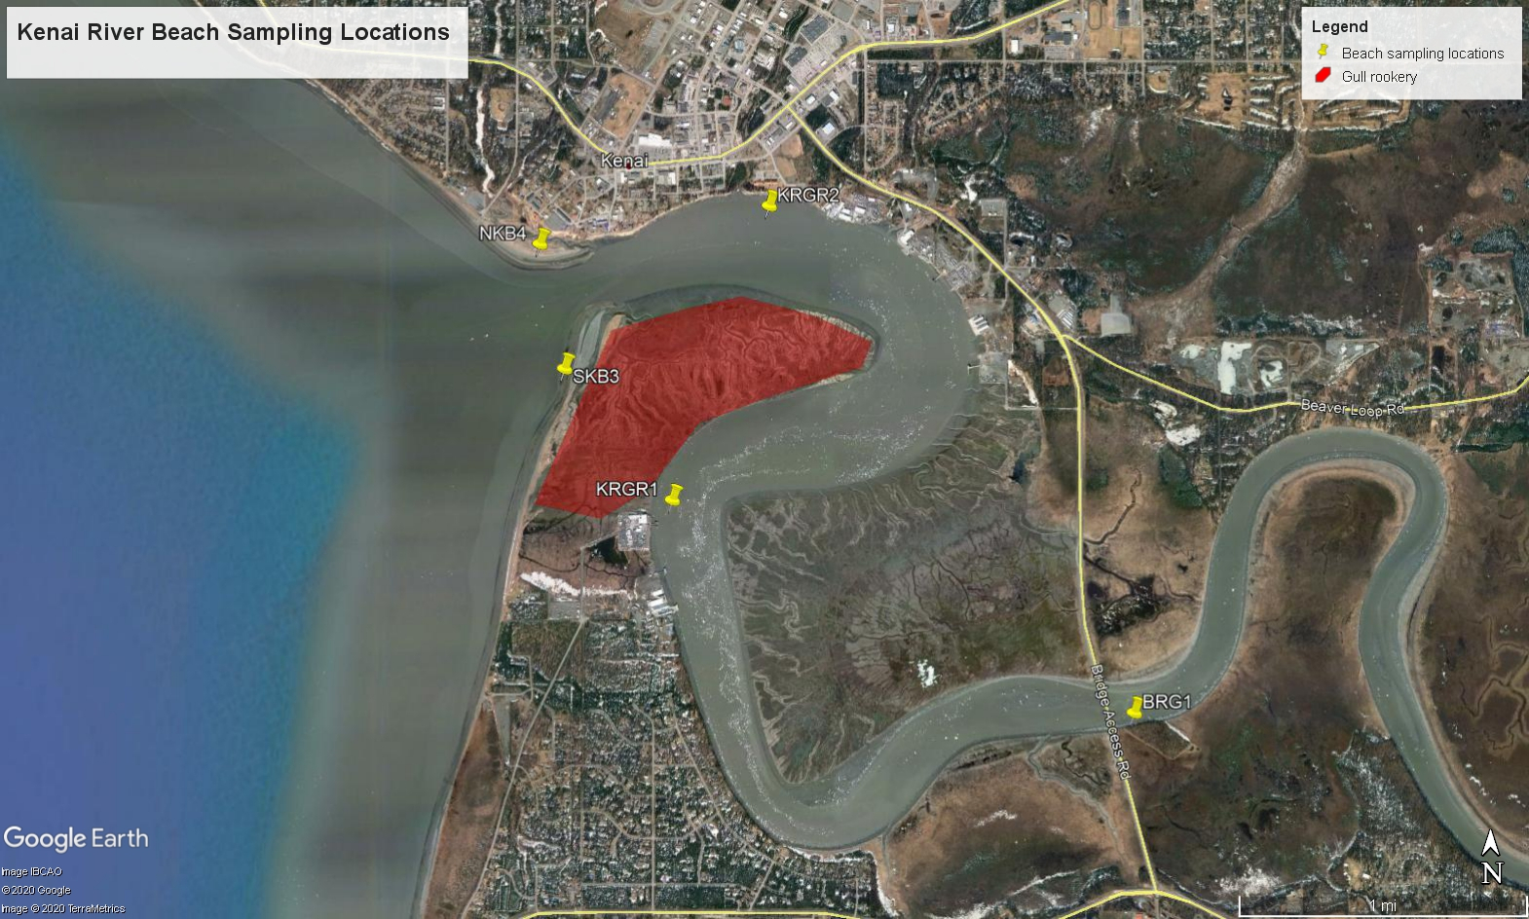

Figure 2. 2019-2020 Kenai River beach sampling sites used for monitoring fecal coliform, enterococci, and microbial source tracking.

## **Sampling design**

Sites selected for monitoring throughout the 2019 and 2020 sampling seasons remained consistent with those used in previous years. These included a sampling site at the Warren Ames Memorial Bridge (BRG1), above and below the gull rookery in the Kenai River (KRGR1 and KRGR2, respectively), and two different areas on both the North (NKB4) and South (SKB3) Kenai Beaches (Figure 2).

During a typical sampling event, morning site visits were conducted within a few hours of high tide. Sites near the gull rookery were accessed by boat while all other sites were accessed by foot. At each site, two 100-mL grab samples of water were collected from the river: one for fecal coliform bacteria and one for enterococci. A set of replicate samples was collected for quality control during each sampling event, rotating between the North and South Kenai Beach sampling sites. In-situ air and water temperatures were collected using a YSI 650 MDS or YSI Pro 20 multiprobe meter; local observations were made regarding the weather, tides, beach, activity noted on the beach, and potential sources of contamination (gulls, boats, etc.). Wave height and turbidity were also assessed in 2020 at the Warren Ames Memorial Bridge and both North and South Kenai Beaches using a yard stick and Hach 2100Q Portable Turbidimeter, respectively. For the purpose of quantifying and referencing observed fishermen, campers, and other beach-goers, the all-encompassing term “recreationists” will be used throughout this report. All field observations were recorded on an EPA Marine Beach Sanitary Survey found in Appendix D.

All grab samples were packaged and shipped on ice with a chain-of-custody form (see Appendix C) within six hours of sampling via commercial air carrier to ADEC-certified laboratory, SGS North America Inc., for analyses in Anchorage. As required by the project QAPP, the quantity of fecal coliform bacteria per 100-mL sample was determined using analytical method ID SM-9222D while the quantity of enterococci per 100-mL sample was determined using analytical method ID D6503-99 (ADEC: Division of Water, 2012). Results of these analyses were reported by the laboratory to Kenai Watershed Forum and ADEC within 48 hours of receiving the samples. If exceedances were present, employees of Kenai Watershed Forum, Alaska Department of Environmental Conservation, and City of Kenai collaboratively acted to alert the public of the risks of exposure and preventative measures to take in order to avoid contact with the contaminated water body. ADEC also produced press releases (Appendix B: Press Releases).

### 2019-2020: Microbial source tracking

Sampling was conducted at all five Kenai River bacteria monitoring locations in 2019 and 2020 for microbial source tracking (MST), a method used to identify sources of fecal contamination based on genetic markers. MST methodology was employed to test for the presence of dog, human, and gull fecal matter- all potential sources contributing to bacteria concentrations in the Kenai River system. In 2019, the first sampling event occurred prior to start of the personal use dipnet fishery on June 4th and a second event occurred on July 23rd. Concentrations of bacteria were not sufficiently elevated for MST analysis in samples from the second sampling event of 2019, thus these samples were not analyzed and ADEC requested a third sampling event, held on August 1st, 2019. In 2020, MST sampling events took place on June 23rd and July 20th.

All sampling events for MST corresponded with a standard bacteria sampling event. Prior to each sampling event, five 500-mL sterile sampling bottles were packaged individually wrapped in paper towels and stored in zip lock bags. Once in the field, personnel cleaned hands and wore new disposable gloves. Sample bottles remained closed until immediately prior to sample collection. Each bottle was labeled with sampling location, sample type (MST), date, and time. One grab sample was taken per monitoring location and subsequently packaged and shipped on ice with a corresponding chain-of-custody form (Appendix C: Chain-of-Custody) within six hours of sampling via commercial air carrier to the ADEC-certified laboratory, SGS North America Inc. (SGS), in Anchorage. To concentrate bacteria within the samples, SGS processed all samples via a sterile, vacuum filtration method. All resulting filters were stored in a freezer until notified by Kenai Watershed Forum to overnight mail the frozen samples with a temperature blank to ADEC-approved Source Molecular in Miami, Florida, where the bacteria source was identified by genetic markers using quantitative polymerase chain reaction (qPCR) and Digital PCR technologies.

## **Quality assurance and quality control**

Data was reviewed for quality control and assurance by the ADEC Project Manager assigned to this monitoring program as well as the Grantee Project Quality Assurance Officer. In addition, a duplicate, quality control sample was taken for both fecal coliform and enterococci analyses. These samples alternated between the North and South Kenai Beaches each week.

As per ADEC CALM (Consolidated Assessment and Listing Methodology) protocol (ADEC, 2019), where two replicate values exist, only the higher of the two values were used in data summary and analyses presented in this report. Additionally, in some cases, where two identical replicate values exist, one may have a qualifier (e.g. "U", indicating the analyte was analyzed for but not detected) and the other does not. In these cases only the result value without the qualifier was retained for data summary and analysis.

All data was uploaded to the state Ambient Water Quality Monitoring System (AQWMS) by ADEC and later to the national EPA Beach Data repository (EPA, 2021a), publically accessible using the online BEACON tool (EPA, 2021b).

## **Water quality standards**

Fecal coliform and enterococci analyses results from the 2019 and 2020 monitoring seasons were evaluated based on the Alaska water quality standards for marine water (18 AAC 70 (14)). Fecal coliform exceedances were determined based on standards set for secondary water recreation and harvesting raw aquatic life for consumption. Exceedances were also identified when > 10% of samples in the prior 30 days exceeded a specified threshold (Table 2).

Criteria for these standards require the results of a minimum of 5 samples (collected weekly) to calculate a 30-day rolling geometric mean. In instances where a 30-day period included a bacterium result of 0 CFU (colony forming units) per 100 mL, this result was not included in the geometric mean calculation.

During the summer monitoring period, weekly exceedances were identified when results exceeded 130 enterococci CFU/100 mL for water recreation (contact recreation), 400 fecal coliform CFU/100 mL for water recreation (secondary recreation), and/or 31 fecal coliform CFU/100 mL for a membrane filtration test for harvesting for consumption of raw mollusks or other raw aquatic life (Table 2). When an exceedance occurred during the personal use dipnet fishery season a public advisory was issued. Advisories were active until two consecutive weeks of bacteria concentrations below exceedance criteria were achieved.

## **Public outreach**

Public outreach remained a critical component of effective bacteria monitoring during the 2019 and 2020 monitoring seasons. ADEC and the City of Kenai partnered with Stream Watch, a Kenai Watershed Forum and U.S. Forest Service program specializing in angler education and outreach, to disseminate information on ways to avoid contact with bacteria and proper fish handling at North Kenai Beach. Education was provided in the form of brochures and personal communication. Booth visitors verbally expressed their appreciation for handouts including fin clippers and dog bags, which aim to help reduce the fecal bacteria contributed by dogs along the beach. Volunteer participation metrics were recorded in 2020 and include staffing a booth for 59 hours during which volunteers conducted peer-to-peer education with 383 recreationists, as well as a total of 93 pounds of trash collected.

To further notify the public, ADEC issued educational radio ads that were played four times per week during the dipnet personal use fishery. In addition, Facebook advisory posts were made containing generalized weekly exceedances of water quality criteria, as well as guidelines for minimizing contact with bacteria, which can be found at <https://dec.alaska.gov/water/water-quality/beach-program/kenai-river-beaches-dipnetting-safety/>. These posts can be found on the ADEC Facebook page: <https://www.facebook.com/AlaskaDEC/>. Two press releases were released in response to site-specific bacteria exceedances in 2019; detailing precautionary

Table 2. 2019-2020 Alaska Department of Environment Conservation water quality standards for fecal coliform and enterococci in marine waters.

|  |  |  |
| --- | --- | --- |
| **Water Quality Standards for Bacteria: Marine Water Uses** | | |
|  | **Fecal coliform** | **Enterococci** |
| **Water recreation:** contact recreation, 18 AAC 70 (14)(B)(i) |  | In a 30-day period, the geometric mean of samples may not exceed 35 enterococci CFU/100 ml, and* not more than 10% of the samples may exceed a statistical threshold value (STV) of **130 enterococci CFU/100 ml.** |
| **Water recreation:** secondary recreation, 18 AAC 70 (14)(B)(ii) | In a 30-day period, the geometric mean of samples may not exceed 200 fecal coliform/100ml, and* not more than 10% of the samples may exceed **400 fecal coliform/100ml.** |  |
| **Harvesting for consumption of raw mollusks or other raw aquatic life,** 18 AAC 70 (14)(D) | The geometric mean of samples may not exceed 14 fecal coliform/100 ml; and* not more than 10% of the samples may exceed; |  |
| - 43 MPN per 100 ml for a five-tube decimal dilution test; |  |
| - 49 MPN per 100 ml for a three-tube decimal dilution test; |  |
| - 28 MPN per 100 ml for a twelve-tube single dilution test; |  |
| ***- 31 CFU per 100 ml for a membrane filtration test (see note 14)\*\*\**** |  |
| MPN = Most Probable Number. Unit equivalent to Colony Forming Unit (CFU). | | |
| *For single-year analysis, "and" is replaced with "or". | | |
| **Standard that was referenced based on analysis methodology used by the laboratory. | | |
| ***Note 14. When fecal coliform levels are monitored in waters designated as state approved shellfish harvesting and growing waters, these waters are also subject to 18 AAC 34.010(19). | | |
| **Bold** text indicates values used to determine exceedances for public notices. | | |
| Alaska Water Quality Standards for Marine Water (18 AAC 70 (14)) | | |

measures the public should take to avoid bacteria-impacted marine water (Appendix B: Press Releases). Emails were sent to local partners each week during the sampling season, summarizing the results from sampling event that week. In 2020 the option to enlist in the email listserv was made available for partners interested in receiving results. ADEC also updated their website to include a beach advisory map in 2020; the map can be found here: <https://dec.alaska.gov/water/water-quality/beach-program/kenai-river/>.

# **Results**

## **Results summary**

Bacteria monitoring efforts in 2019-2020 revealed instances of criteria exceedance based on the Alaska Water Quality Standards for consumption of raw aquatic life at all five sites, for contact recreation at two sites (South Kenai Beach and North Kenai Beach), and for secondary recreation at one site (South Kenai Beach). Some differences between 2019 and 2020 were evident. At the North and South Kenai Beach sites in particular, enterococci and fecal coliform concentrations were generally lower in 2020 relative to 2019. Microbial Source Tracking using species-specific genetic markers revealed that gulls were overwhelmingly the source of most fecal matter at all sites.

## **Bacteria concentrations monitoring 2019 - 2020**

A total of 161 enterococci samples and 162 fecal coliform sample concentrations, including replicates, are present in the 2019-2020 data set. The two beach sites at the mouth of the Kenai River exhibited exceedances of several criteria thresholds for both enterococci and fecal coliform throughout the 2019-2020 sampling seasons, while the upstream sites at the two gull rookeries and Warren Ames Bridge exhibited exceedances generally lower in concentration and duration, and only for fecal coliform (Figure 3).

All five sites exhibited instances of exceedance of thresholds for consumption of raw aquatic life (fecal coliform 30-day geometric mean > 14 CFU/mL or 10% of fecal coliform samples from prior 30 days > 31 CFU/mL). In addition, the North and South Beach sites saw exceedances of criteria for contact recreation (enterococci 30-day geometric mean > 35 CFU/mL or 10% of enterococci samples from prior 30 days > 130 CFU/mL). The South Kenai Beach site saw the greatest magnitude and frequency of criteria exceedances for both bacteria, with some instances of thresholds surpassed for secondary recreation (10% of fecal coliform samples from prior 30 days > 400 CFU/mL) (Figure 3).

Variation between replicate samples averaged 40.62 ± 4.80 % (mean ± std. error) for enterococci and 23.82 ± 2.86 % (mean ± std. error) for fecal coliform samples (Table 3).

For complete data applied in determining threshold criteria exceedance see Appendix E: Samples Values and Exceedances. Raw analytical results can also be found at <https://dec.alaska.gov/water/water-quality/beach-program/kenai-river/>.

Table 3. Mean percent difference between replicate sample values.

|  |  |  |
| --- | --- | --- |
| **Bacteria** | **Samples** | **% Difference Between Replicates (Mean ± Standard error)** |
| Enterococci | 54 | 40.62 ± 4.80 % |
| Fecal Coliform | 54 | 23.82 ± 2.86 % |

## **Enterococci**

Enterococci exceedances were observed at the North and South Kenai Beach sites only for 2019-2020 (Figure 4). North and South Kenai Beach saw generally lower enterococci values in 2020 relative to 2019 Geometric mean enterococci values at South Kenai Beach in 2019 ranged from 12.44 – 126.12 CFU/100 mL, averaging 83.46 ± 14.06 CFU/mL (mean ± std. error). 2020 South Kenai Beach enterococci values were notably lower, ranging 14.54 – 39.75 CFU/mL, averaging 29.09 ± 2.79 CFU/mL (mean ± std. error). At North Kenai Beach in 2019, geometric means for enterococci ranged 9.43 – 29.21 CFU/mL, averaging 37.64 ± 7.96 CFU/mL (mean ± std. error). 2020 North Kenai Beach enterococci geometric mean values were also lower, ranging 2.61 – 10.02 CFU/mL, averaging 6.05 ± 0.76 (mean ± std. error) (Table 4).

## **Fecal Coliform**

In contrast to enterococci, exceedances of fecal coliform criteria (harvesting raw mollusks or other raw seafood for consumption) occurred at all five sampling sites in 2019 and 2020 (Figure 4). Exceedances of criteria for water recreation based on fecal coliform were seen at three sites 2019, and at two sites in 2020. As with enterococci, fecal coliform sample concentrations were generally lower in 2020 relative to 2019.

Fecal coliform sampling results from the South Kenai Beach in 2019 resulted in a range in geometric means of 12.86 – 182.12 CFU/100 mL, averaging 69.23 ± 17.95 CFU/100 mL (mean ± std. error). 2020 geometric mean values were on average lower, ranging from 14.54 – 39.75 CFU/mL, averaging 29.09 ± 2.79 (mean ± std. error) (Table 4).

At North Kenai Beach in 2019, fecal coliform geometric mean values ranged from 5.38 – 75.07 CFU/mL, averaging 36.51 ± 7.00 (mean ± std. error). 2020 geometric mean values were again on average lower, ranging from 7.03 – 20.33 CFU/mL, averaging 12.84 ± 1.66 CFU/mL (mean ± std. error) (Table 4).

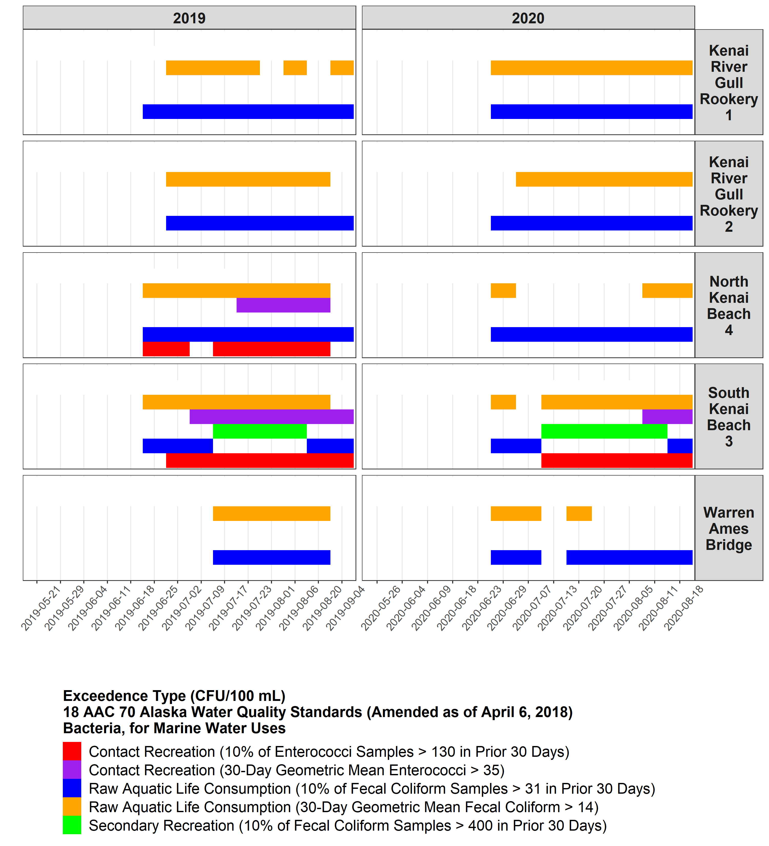

Figure 3: Duration of criteria exceedance type for each site sampled in the lower Kenai River, 2019 – 2020.

Table 4: Summary values for 30-day geometric mean concentrations of bacteria from sampling sites in the lower Kenai River, 2019 – 2020.

|  |  |  |  |  |  |
| --- | --- | --- | --- | --- | --- |
| **Location** | **Bacteria** | **Year** | **Mean ± Std. Error 30-Day Geometric Mean (CFU/mL)** | **Maximum 30-Day Geometric Mean (CFU/mL)** | **Minimum 30-Day Geometric Mean (CFU/mL)** |
| Kenai River Gull Rookery 1 | Enterococci | 2019 | 9.37 ± 2.62 | 21.23 | 3.38 |
| 2020 | 7.84 ± 0.65 | 10.37 | 4.02 |
| Fecal Coliform | 2019 | 21.58 ± 4.73 | 55.99 | 10.89 |
| 2020 | 61.09 ± 8.08 | 94.87 | 33.52 |
| Kenai River Gull Rookery 2 | Enterococci | 2019 | 10.40 ± 1.26 | 14.88 | 3.18 |
| 2020 | 4.52 ± 0.62 | 8.24 | 2.83 |
| Fecal Coliform | 2019 | 29.19 ± 5.86 | 53.62 | 6.66 |
| 2020 | 18.90 ± 1.32 | 24.43 | 12.62 |
| North Kenai Beach 4 | Enterococci | 2019 | 37.64 ± 7.96 | 69.21 | 9.43 |
| 2020 | 6.05 ± 0.76 | 10.02 | 2.61 |
| Fecal Coliform | 2019 | 36.51 ± 7.00 | 75.07 | 5.38 |
| 2020 | 12.84 ± 1.66 | 20.33 | 7.03 |
| South Kenai Beach 3 | Enterococci | 2019 | 83.46 ± 14.06 | 126.12 | 12.44 |
| 2020 | 29.09 ± 2.79 | 39.75 | 14.54 |
| Fecal Coliform | 2019 | 69.23 ± 17.95 | 182.12 | 12.86 |
| 2020 | 47.01 ± 8.71 | 79.44 | 13.05 |
| Warren Ames Bridge | Enterococci | 2019 | 2.76 ± 0.34 | 4.74 | 1.74 |
| 2020 | 1.48 ± 0.10 | 1.89 | 1.00 |
| Fecal Coliform | 2019 | 18.16 ± 3.28 | 34.81 | 7.27 |
| 2020 | 11.22 ± 1.34 | 15.92 | 6.01 |

In response to criteria exceedances, ADEC issued a press release on June 6, 2019 for the North Kenai Beach for water impacted by elevated concentrations of enterococci and fecal coliform. Later that month, a press release was issued on June 20, 2019, lifting the advisory for enterococci on the North Kenai Beach while implementing one for water impacted by elevated concentrations of fecal coliform at both North and South Kenai Beaches and the upstream Kenai Gull Rookery sampling site for consumption of raw seafood. The final press release was issued on July 5, 2019 for waters impacted by elevated concentrations of fecal coliform and enterococci at both North and South Kenai Beaches as well as both Kenai Gull Rookery sampling sites. These exceedances occurred for both contact water recreation and consumption of seafood. All press releases can be found in Appendix B: Press Releases. In 2020, an initial general press release was issued on May 18, 2020 and subsequent notifications posted on the DEC Facebook page.

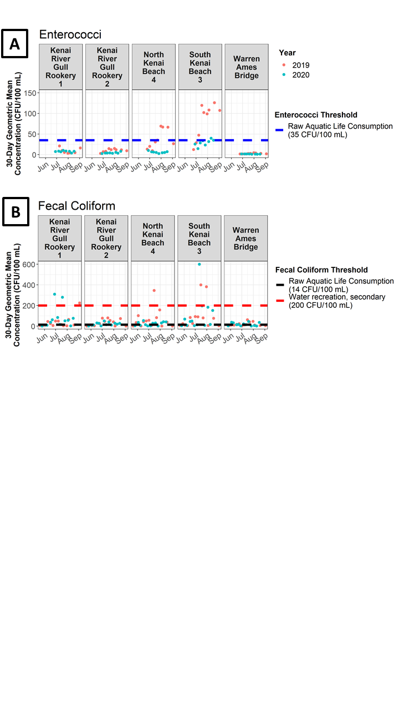

Figure 4: 30-day geometric mean values for enterococci (A) and fecal coliform (B) at sites sampled in the lower Kenai River, 2019 – 2020. Threshold standards from 18 AAC 70 Alaska Water Quality Standards (amended as of April 6, 2018)-(14) Bacteria, for Marine Water Uses.

## **2019 - 2020 Microbial Source Tracking Data**

Sample results for microbial source tracking (MST) were available for two sampling events for each of the 2019 – 2020 sampling seasons. In general, gulls were indicated as the overwhelming source of fecal matter at most sampling events (Figure 5). Concentrations of dog and human feces were detected in some cases, but in general were much lower relative to concentrations of gull feces. Human fecal matter was detected at all sites except the Warren Ames Bridge, while dog fecal matter was detected only at the North and South Kenai Beach sites. Concentrations (copies biomarker gene/100 mL) overall ranged from not detected to 28,200 for gulls, not detected to 4,660 for dogs, and not detected to 1,220 for humans.

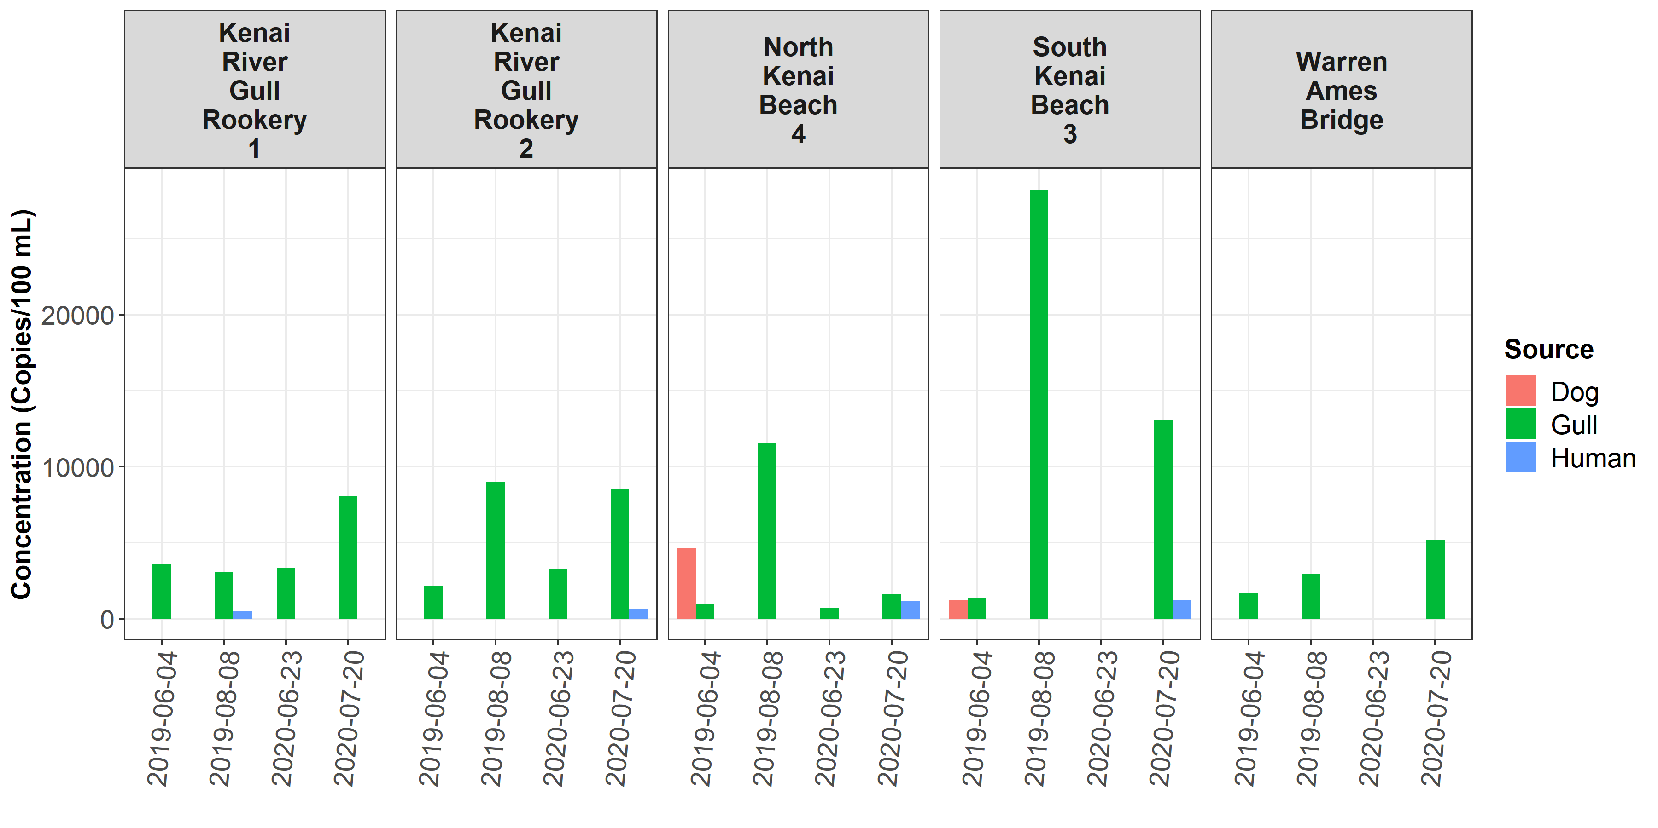

Figure 5: Results from microbial source tracing (MST) analyses from the dive sites sampled for bacteria in the lower Kenai River, 2019 – 2020. Values are copies of biomarker gene per 100 mL. Where colored bars are absent, genetic material was either not detected or detected but not quantifiable. See appendix X for data used to generate this figure.

While human and dog fecal matter were generally much lower relative to gull fecal matter in most sampling events, several exceptions are noted. Sampling events on June 4, 2019 indicated dog feces as the majority source of fecal contamination at North Kenai beach and as a substantial source, proportionately, at South Kenai Beach. Additionally, on July 7, 2020 at North Kenai beach, fecal matter concentrations for gulls and humans were within a similar range of values, with 1590 marker copies/100 mL for gulls and 1140 marker copies/100 mL for humans (Figure 6.) Complete MST data is found in Table 5 (Appendix F: Microbial Source Tracing Data).

# **Discussion**

## **2019-2020 Kenai beach bacteria monitoring**

Throughout the 2019 - 2020 bacteria monitoring seasons, enterococci and fecal coliform exceedances occurred consistently at the North and South Kenai Beach sites, with exceedances of greater duration and magnitude at the South Kenai beach site. Exceedances of lesser duration and magnitude also occurred at the other sampling sites. The elevated concentrations of bacteria at North and South Kenai Beach relative to other locations can likely be attributed to the increase in fish carcasses and gull fecal matter during the dipnet personal use fishery in July.

Exceedances for fecal coliform criteria occurred at all five sampling locations during the 2019 and 2020 monitoring seasons, while enterococci exceedances were observed only at the North and South Kenai Beach sites in 2019, and only at the South Kenai Beach in 2020.

Exceedances for enterococci for geometric mean thresholds at North Kenai Beach were in effect 44.4% of sample days in 2019 and 0% of sample days in 2020; and at South Kenai Beach for 77.8% of sample days in 2019 and 25.0% of sample days in 2020. Exceedances of the uppermost magnitude for fecal coliform (secondary recreation; 10% of samples from the prior 30 days > 400 CFU/mL) were observed only at the South Kenai Beach site, and were in effect for 28.6% of sample days in 2019 and 35.7% of sample days in 2020 (Figure 6).

Though various factors influence the magnitude of bacteria concentrations in the lower Kenai River, the size and timing of the late-run sockeye population and personal use dipnet fishery participation are likely among the largest. When more fish carcasses are disposed of on the beach, greater quantities of gull fecal matter contribute to bacteria growth unless mitigated. Annual participation in the Kenai River personal use dipnet fishery continues to grow (Figure 7), thus monitoring and assessment of bacteria concentrations in the lower Kenai River will continue to remain essential. Even in spite of the travel challenges posed by the COVID-19 pandemic in summer 2020, overall revenue from – and thus participation in – the personal use dipnet fishery in 2020 was up relative to 2019 ($367,982 in 2019, $456,411 in 2020) (Ostrander, 2020). Although the 2020 harvest was likely lower than 2019 due to the late arrival of a substantial portion of the late-run sockeye (Figure 8), in general there is a close relationship between dipnet fishing effort and total annual harvest (Cenek and Franklin, 2017).

The limited time span of data (2019-2020) addressed in this report makes ranking the importance of various factors that contribute to bacteria exceedances to challenging. A future analysis that includes a full assessment of all available bacteria concentrations data from 2010 - present in the context of likely predictors (e.g. size and timing of fishery harvest, river flow volume, water temperature, mitigation actions, etc.) may permit attribution of frequency or duration of exceedances to specific predictors. An especially valuable exploration of this data would include evaluating the effects of mitigation actions, such as beach raking, on bacteria concentrations, in order to allow managers to most effectively implement this management tool (e.g. Kinzelman et al. 2004). It is important to remember that assessments of BMPs and their effect on frequency and magnitude of exceedances should be evaluated in the context of the growing popularity of the personal use dipnet fishery (Figure 7).

It is recommended that ADEC continue to work closely with the City of Kenai to effectively implement best management practices based on dipnet personal use fishery attendance and beach carcass concentrations. Should future needs dictate, a modification of best management

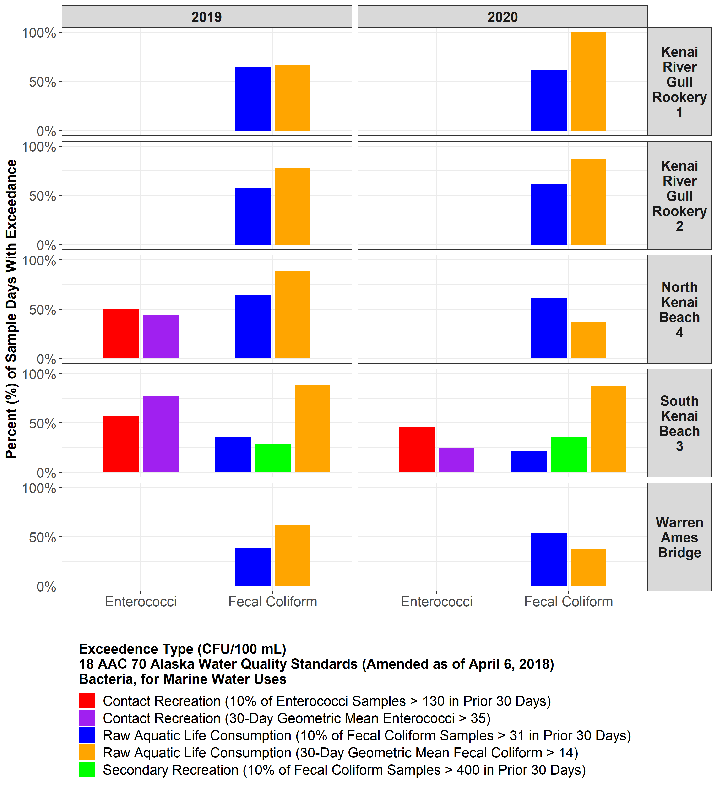

Figure 6: Percent of sample days where bacteria sample values exceeded criteria thresholds, 2019 – 2020 lower Kenai River. Missing bars indicate that 0% of sample days exhibited criteria threshold exceedance.

practices to include disposal or compost of carcasses could be a more permanent, effective way to mitigate the effects on bacteria concentrations.

Employing the full extent of all available management and environmental data from the lower Kenai River personal use dipnet fishery will be increasingly important in subsequent years, as weekly monitoring of bacteria concentrations may not include in situ weekly sample collection

(S. Apsens (ADEC), personal communication, 2020a). An implementation of the Environmental

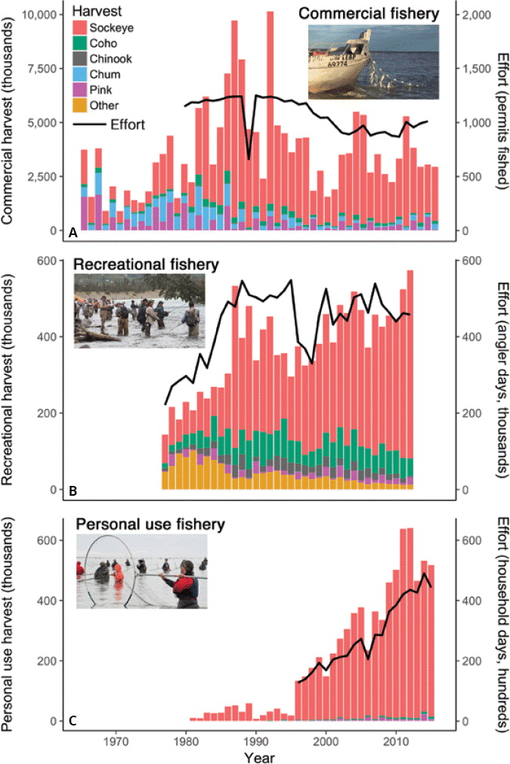

Figure 7: Growth of the Kenai River personal use fishery in harvest (left axis) and effort (right axis). The fishery has historically captured almost exclusively sockeye salmon (red color), through small numbers of other salmon species are also captured, represented by other colors stacked at the bottom of each bar. Data from ADF&G; figure adapted from Schoen et al. 2017 with author’s permission.

Protection Agency's Virtual Beach Model (EPA, 2021c) is planned, and will be used to estimate in-river bacteria concentrations, supported by two to three in situ “spot checks” throughout the summer where physical samples are collected. Moving forward, it is recommended that the full extent of historical data be used to parameterize the Virtual Beach model, and that sufficient data continue to be collected in order to support it, and that the model is regularly evaluated using both in-season spot checks and comparison to hindcasted values.

Some evidence suggests that for this data set, criteria standards that assess whether 10% of samples from the previous thirty days exceed a threshold may be less appropriate to represent actual in-river conditions. Replicate grab samples of environmental media can be prone to inter- sample variation (Royal Society of Chemistry, 2014). In this report, difference among paired replicate samples averaged approximately 40% for enterococci and 24% for fecal coliform. Previous reports also indicate substantial variation among sample values within a relatively small time span. In 2013, at some sites on North and South Kenai Beach where samples exceeded thresholds, they did not do so when re-sampled twenty-four hours later (Guerron Orejuela, 2013). In 2018, North and South Kenai Beach sites were sampled at hourly intervals for one twenty-four hour cycle in July, and bacteria concentrations varied by an order of magnitude (Harings, 2019). For the overall data set 2010 - 2020 consisting primarily of weekly sampling, the weekly interval may be too coarse to meaningfully apply criteria that refer to 10% of samples exceeding a threshold in the past 30 days. In contrast, criteria that instead assess thirty-day

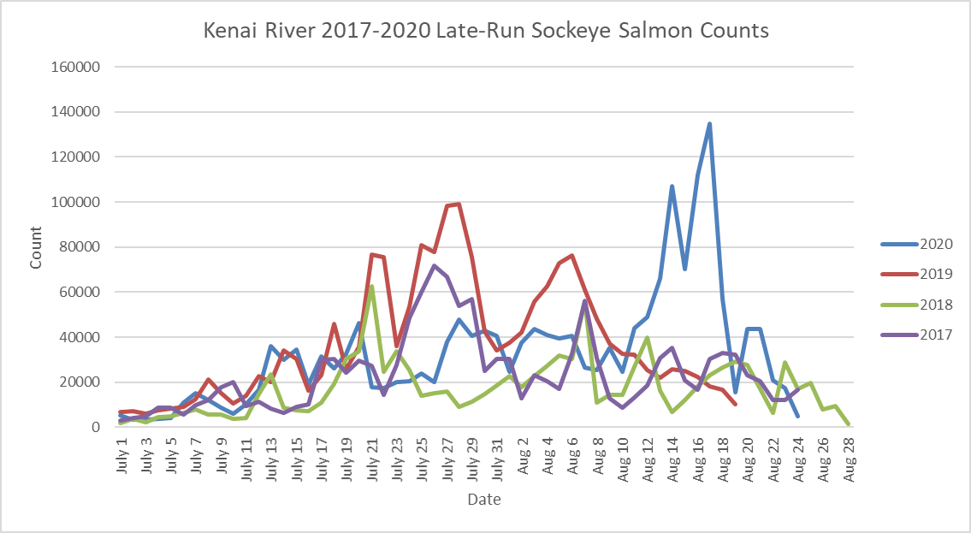

Figure 8: 2017 – 2020 late run sockeye salmon counts on the Kenai River. Data sourced from Alaska Department of Fish and Game (ADF&G, 2020).

rolling geometric mean values are less prone to short-term variations and thus more likely to represent actual in-river conditions. It is recommended that water quality criteria employing these standards to so in the context of mean replicate variation, and also be compared to standards that employ rolling geometric means.

Finally, continuing open communication with local stakeholders will remain a critical component of successful and meaningful bacteria monitoring. Emails to stakeholders summarizing weekly sampling results have shown to be effective for conveying data in a transparent manner. Public education and outreach events have also been proven effective, and should continue during future monitoring seasons. Public advisories have reached thousands of radio listeners and Facebook viewers. Going forward, it is recommended that protocol is annually reviewed to maintain consistency in when advisories are issued and subsequently removed after two weeks of bacteria concentrations below exceedance threshold (Figure 3 in ADEC, 2020b).

### 2019-2020 Microbial source tracking

Limited MST data had been gathered during previous Kenai bacteria monitoring events prior to 2019 - 2020. Historically, sample analysis for MST was conducted in 2011 and 2014; results can be found here: <https://dec.alaska.gov/water/water-quality/beach-program/>.

MST samples analyzed from the 2019 - 2020 sampling events reported gull feces at all five sampling sites. Among both years, the highest concentration of marker copies associated with gull fecal matter were detected at both North and South Kenai beach sites. This is likely due to the increase in the number of carcasses (and therefore gulls) along the beaches during the personal use dipnet fishery. For June 2020 MST sampling, both Kenai gull rookery sampling sites displayed higher levels of gull feces than any other site, likely due to their proximity to the rookery itself. Quantifiable results for gull feces were reported at all five sites in July during the dipnet personal use fishery during which marker copies were one order of magnitude higher at South Kenai Beach than any other sampling site.

For comparison among 2019 and 2020, concentration of gull marker copies was roughly twice as high at North and South Kenai Beaches in 2019 than in 2020, which may be attributable to the delayed run timing (and thus likely lower personal use fishery harvest and carcass disposal) of late-run sockeye in 2020.

Finally, it is critical to note that the mouth of the Kenai is a dynamic and ever-changing zone. Influenced by fluctuating river discharge, tides, wind, and boat traffic, patterns in water flow can vary by the minute. Therefore, each MST result is a snapshot of conditions at that time and location-not necessarily a representation of the water in an area as a whole.

# **Conclusions and recommendations**

Data collected throughout 2019 and 2020 provide insight into some of the factors involved in the fluctuation of bacteria concentrations in the lower Kenai River and the sources of these bacteria throughout the summer months. Moving forward, the following recommendations should be taken into consideration:

1. North and South Kenai Beach continue to experience bacteria exceedances each year. In 2019 and 2020, South Kenai Beach exhibited exceedances of generally greater duration and magnitude. Both beaches are impacted by an increase in salmon carcasses and therefore gulls during the dipnet personal use fishery.
   1. Additional research surrounding patterns in tidal currents and river outflow at the mouth of the Kenai River is highly recommended, as these patterns may inform the discrepancy in bacteria concentrations between North and South beaches.
   2. It is recommended that ADEC work with the City of Kenai to assess the effectiveness of current BMPs and modify if necessary. With a long term time series, the effectiveness of BMPs may be evident in the data, though trends should be evaluated in the context of the growth of the personal use fishery in the past two decades. One modification of BMPs could include requiring the immediate disposal or composting of carcasses on the beach.
2. Consistent communication with stakeholders and user groups will remain critical to effective beach monitoring. Protocol should be annually reviewed to ensure consistency in when public advisories are issued and for what sites they are necessary.
3. Because MST analyses provide results for single-sample events, results from 2019-2020 provide a snapshot of bacteria marker copy concentrations at the time of sampling. Due to extremely dynamic patterns in current at the mouth of the Kenai, more consistent sampling for MST is recommended in order to assess spatiotemporal variation in bacteria sources.
4. In the future, annual reports should evaluate annual results in the context of available long-term data sets. Comparing new data to long term trends is essential to ensure that ecological trends are readily recognizable even as staff and personnel involved with monitoring may change.
5. Data collection for additional parameters including wave height is recommended in future years in order to effectively implement EPA's Virtual Beach Model. In the future, this modeling could inform the amount of sampling required to effectively issue public advisories for bacteria.
   1. Using the results of the Virtual Beach Model, it is advised that a monitoring program be operated in perpetuity in order to issue public advisories when necessary.

These five actions would support educated management decisions, encourage preservation of environmental habitat, mitigate potential public health issues, and ensure transparency of the beach monitoring process.

# **Data availability**

All data and R programming scripts used in this analysis is available in a public repository at <https://github.com/Kenai-Watershed-Forum/KWF_Beach_Sampling_2019_2020>.

# **References**

Alaska Department of Environmental Conservation (ADEC). (2018). *2018 Water Quality Standards*.

Alaska Department of Fish and Game. (2018). *Kenai River boat and shore dipnet areas* [Digital image]. Retrieved December 12, 2018, from [www.adfg.alaska.gov/index.cfm?adfg=personalusebyareasouthcentralkenaisalmon.main](http://www.adfg.alaska.gov/index.cfm?adfg=personalusebyareasouthcentralkenaisalmon.main).

Alaska Department of Fish and Game. (2020). Kenai River late-run sockeye. <https://www.adfg.alaska.gov/sf/FishCounts/>. Accessed January 11, 2021.

Alaska Department of Environmental Conservation (ADEC). (2012). *Kenai BEACH Water Quality Monitoring and Pathogen Detection: Quality Assurance Project Plan, Rev. 3*.

Alaska Department of Environmental Conservation (ADEC). (2012). *Kenai BEACH Water Quality Monitoring and Pathogen Detection: Quality Assurance Project Plan, Rev. 4*.

Alaska Department of Environmental Conservation (ADEC). (2019). *Alaska Consolidated Assessment and Listing Methodology (CALM) for 2020 Integrated Report on Water Quality.*

<https://dec.alaska.gov/media/15688/alaska-consolidated-assessment-listing-methodology-for-2020-integrated-report.pdf>

Alaska Department of Environmental Conservation (ADEC). (2020a). Personal communication on 2021 bacteria monitoring program, S. Apsens, December 2020.

Alaska Department of Environmental Conservation (ADEC). (2020b). *Beach Monitoring Handbook Kenai River Beaches, Rev. 3.* <https://dec.alaska.gov/media/20323/2020-kenai-beach-sampling-handbook.pdf>

5 AAC 21.360, Alaska Admin Code. (2020). *Kenai River Late Run Sockeye Salmon Management Plan*. <http://www.legis.state.ak.us/basis/aac.asp#5.21.360>.

Cenek, M., Franklin, M. (2017). *An adaptable agent-based model for guiding multi-species Pacific salmon fisheries management within a SES framework*. Ecological Modelling **2017**, *360*(24), 132-149, <https://doi.org/10.1016/j.ecolmodel.2017.06.024>.

Environmental Protection Agency (EPA). 2021a. Submitting Beach Data to EPA. <https://www.epa.gov/beach-tech/submitting-beach-data-epa>. Accessed Jan 8, 2021.

Environmental Protection Agency (EPA). 2021b. EPA BEACON. <https://watersgeo.epa.gov/beacon2/>. Accessed January 8, 2021.

Environmental Protection Agency (EPA). 2021c. Environmental Modeling Community of Practice: Virtual Beach. <https://www.epa.gov/ceam/virtual-beach-vb>. Accessed January 11, 2021.

Guerron Orejuela, E. (2014). City of Kenai Kenai River Beach Sampling FY 2014 Final Report. <https://scholarcommons.usf.edu/geo_studpub/76/>. Accessed January 11, 2021.

Green, H., Welker, D., Johnson, S., Michalenko, E. (2019). Microbial Source-Tracking Reveals Origins of Fecal Contamination in a Recovering Watershed. Water, 11(10), 2162. <https://doi.org/10.3390/w11102162>.

Harings, M. (2019). 2018-2019 Kenai Beach Bacteria Monitoring Report. Kenai Watershed Forum. <https://dec.alaska.gov/media/21000/kenai-river-beach-2019-final-reportadec.pdf>. Accessed January 11, 2021.

Kinzelman, J.L., Pond, K. R., Longmaid, K. D., Bagley, R. C. (2004). The effect of two mechanical beach grooming strategies on *Escherichia coli* density in beach sand at a southwestern Lake Michigan beach. *Aquatic Ecosystem Health & Management, 7*(3), 425-432. <https://doi.org/0.1080/14634980490483953>

Ostrander, P. (2019). *2019 Personal Use Fishery (Dip Net) Report*. Kenai, Alaska: City of Kenai.

Ostrander, P. (2020). *2020 Personal Use Fishery (Dip Net) Report*. Kenai, Alaska: City of Kenai.

Royal Society of Chemistry. (2014*). Estimating sampling uncertainty–how many duplicate samples are needed?* Analytical Methods, 6(24), 24-26. <https://www.rsc.org/images/sampling-uncertainty-58_tcm18-237148.pdf>.

Schoen, E. R., Wipfli, M. S., Trammell, E. J., Rinella, D. J., Floyd, A. L., Grunblatt, J., McCarthy, M. D., Meyer, B. E., Morton, J. M., Powell, J. E., Prakash, A., Reimer, M. N., Stuefer, S. L., Toniolo, H., Wells, B. M., & Witmer, F. D. W. (2017). Future of pacific salmon in the face of environmental change: Lessons from one of the world’s remaining productive salmon regions. *Fisheries*, *42*(10), 538–553. [https://doi.org/10.1080/03632415.2017.1374251](http://dx.doi.org/10.1080/03632415.2017.1374251)

## **Appendix A: Site Photographs**

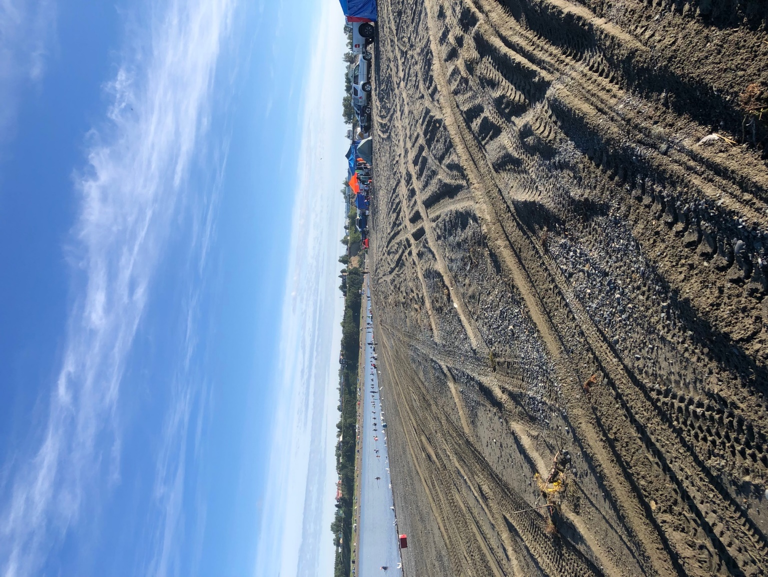

South Kenai Beach 3 sampling location looking toward the Kenai River outlet. North Kenai Beach can be seen in the background. Photo taken on July 27, 2020 during the personal use dipnet fishery season.

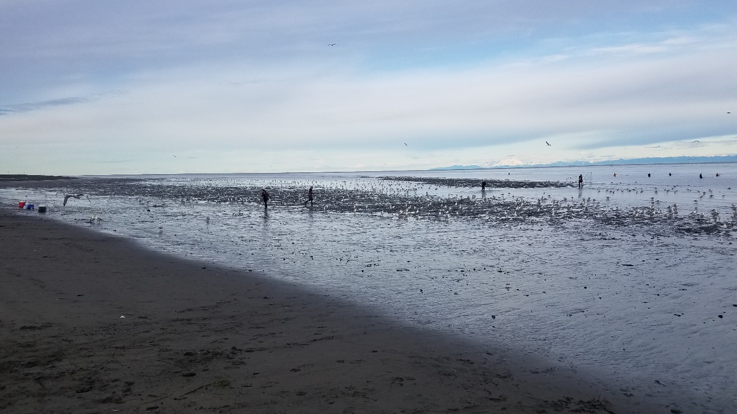

South Kenai Beach 3 sampling location depicting the highest gull count of the sampling season. Photo taken on July 20, 2020 during the personal use dipnet fishery season.

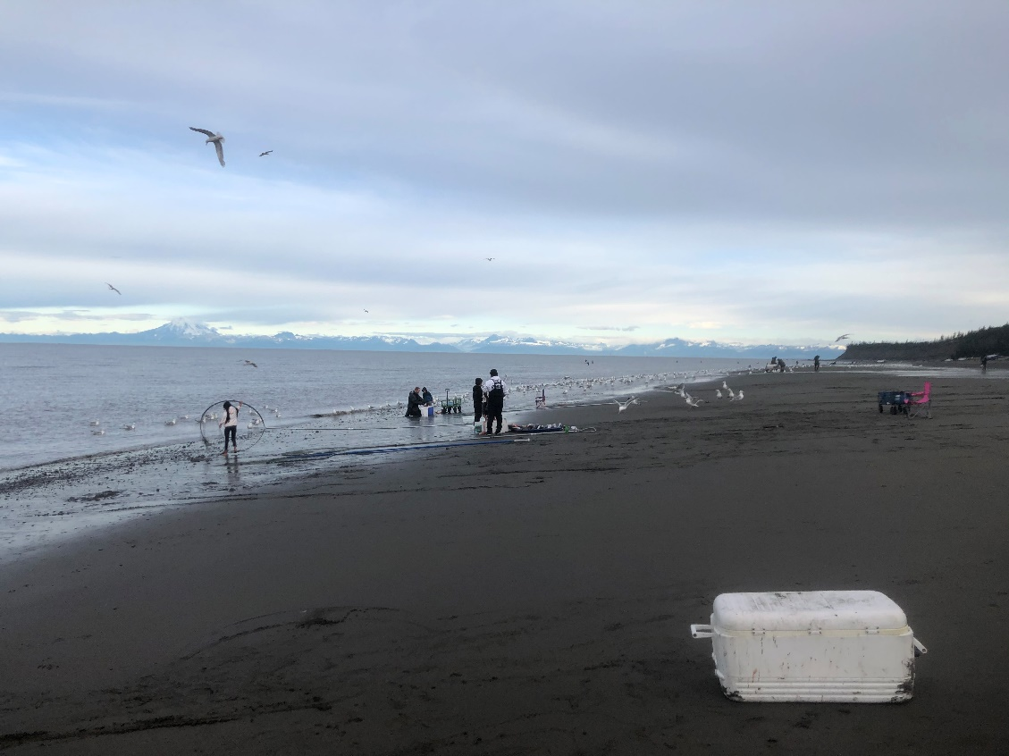

North Kenai Beach 4 sampling location. Photo taken on July 20, 2020 during the personal use dipnet fishery season.

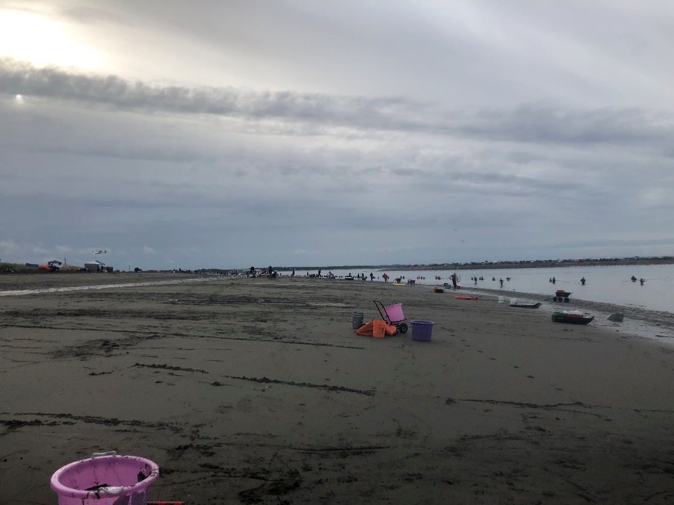

North Kenai Beach 4 sampling location looking away from the Kenai River outlet. Photo taken on July 23, 2019 during the personal use dipnet fishery season.

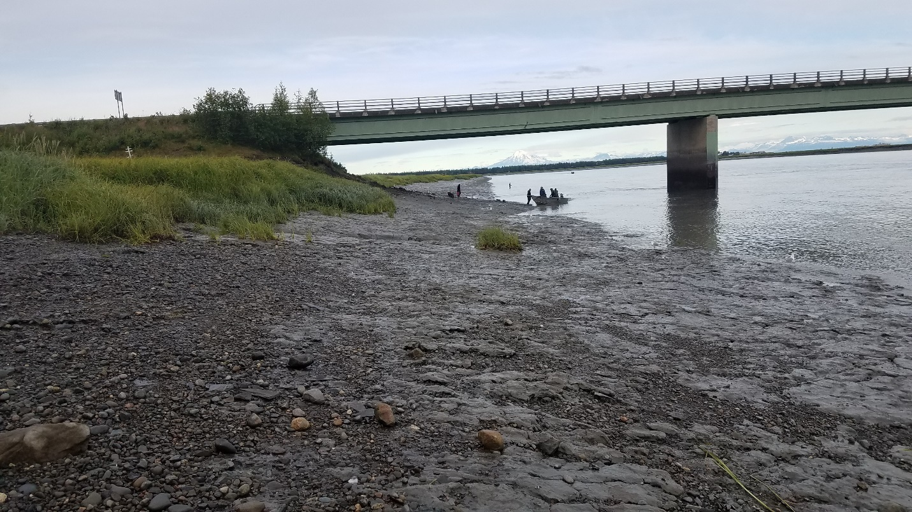

Warren Ames Memorial Bridge 1 sampling location looking downstream on the Kenai River. Photo taken on July 20, 2020 during the personal use dipnet fishery season.

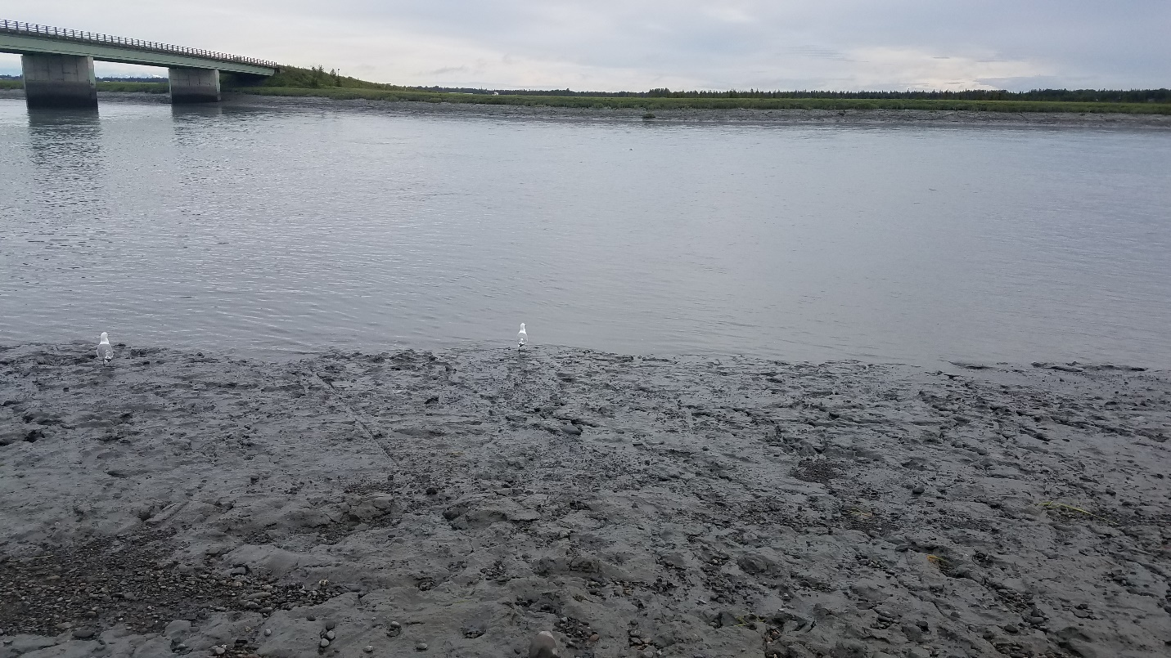

Warren Ames Memorial Bridge 1 sampling location on the Kenai River. Photo taken on July 20, 2020 during the personal use dipnet fishery season.

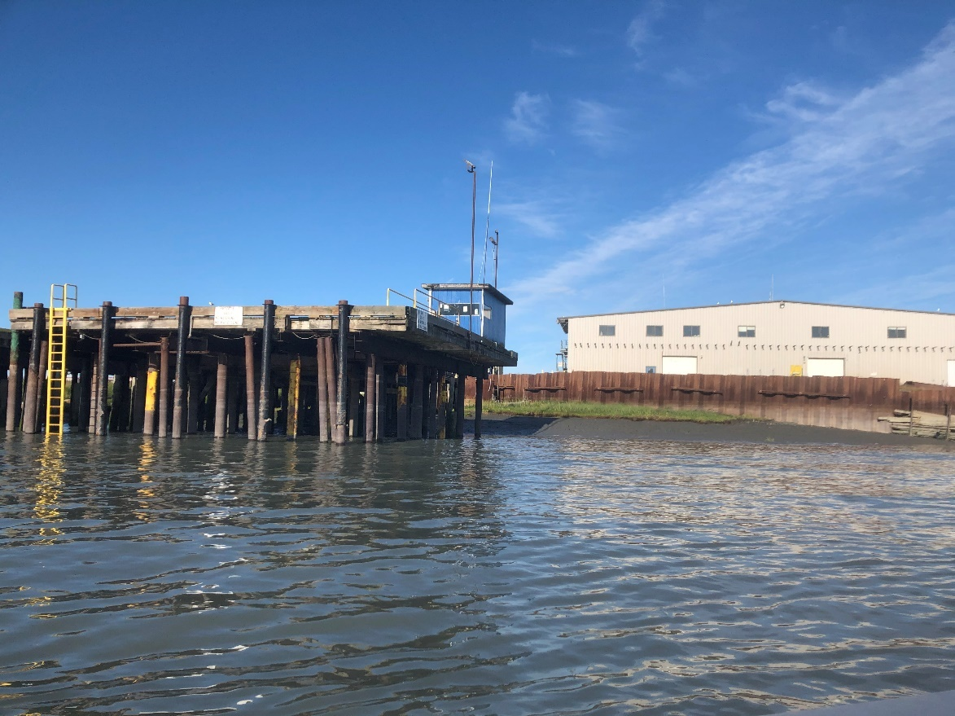

Kenai Gull Rookery 1 sampling location. The fish processing plant can be seen in the background. Photo taken on July 27, 2020 during the personal use dipnet fishery season.

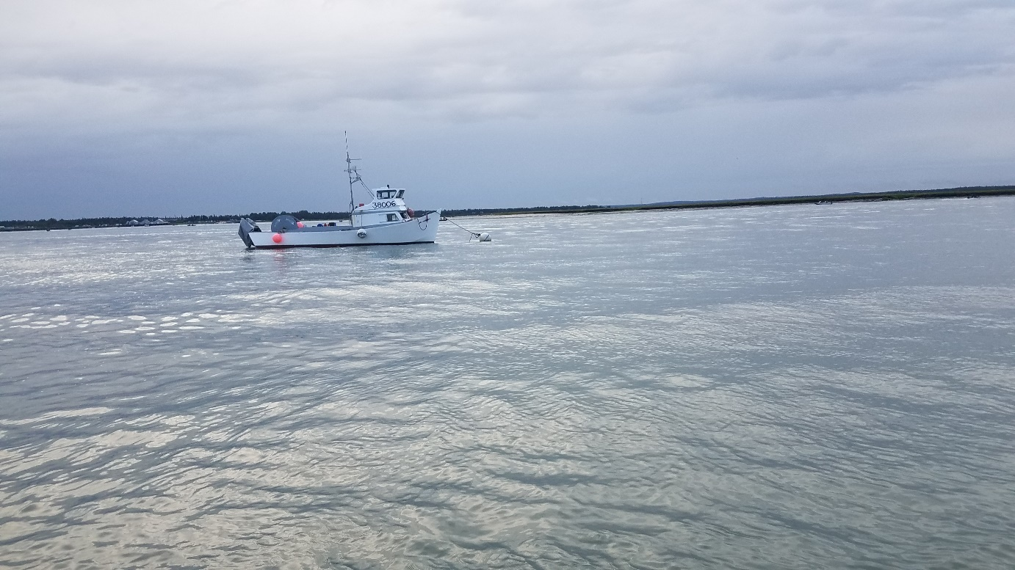

Kenai Gull Rookery 1 sampling location looking across the Kenai River. Dipnetting boats can be seen along the far shore behind the mooring boat. Photo taken on July 20, 2020 during the personal use dipnet fishery season.

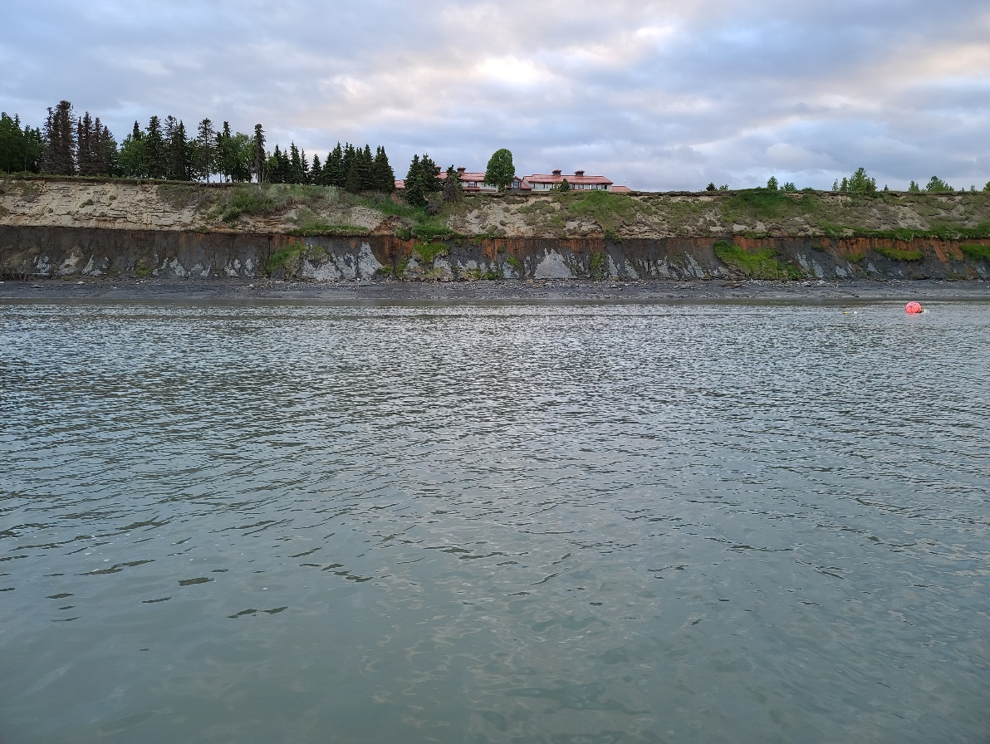

Kenai Gull Rookery 2 sampling location looking at river-right bank. Photo taken on June 18, 2020.

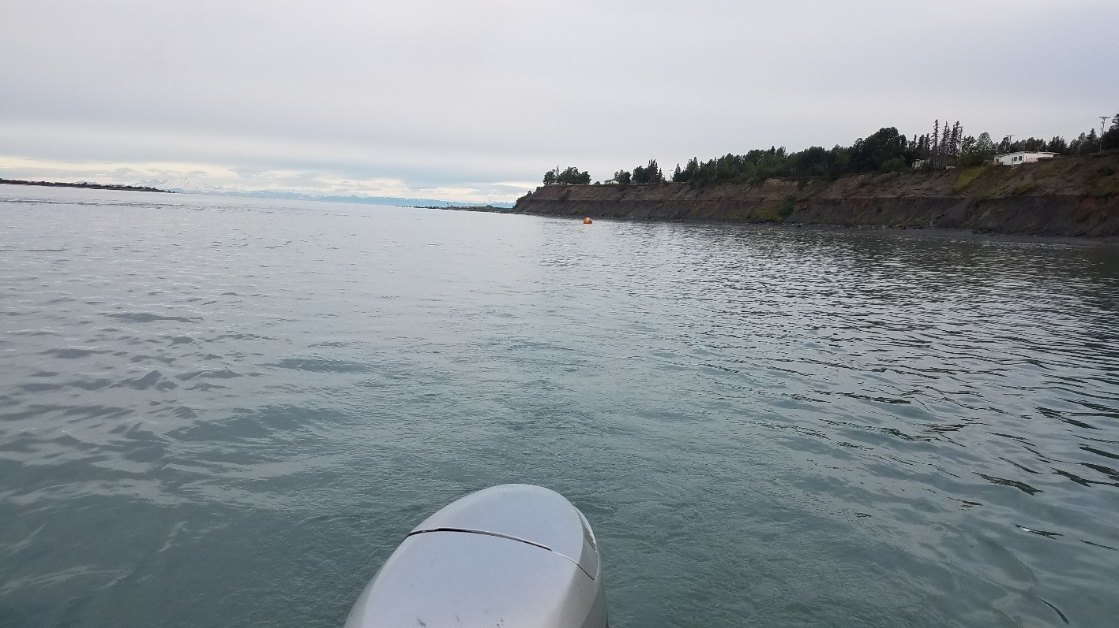

Kenai Gull Rookery 2 sampling location looking downstream toward Kenai River outlet and Cook Inlet. Photo taken on July 20, 2020 during the personal use dipnet fishery season.

## **Appendix B: Press Releases**

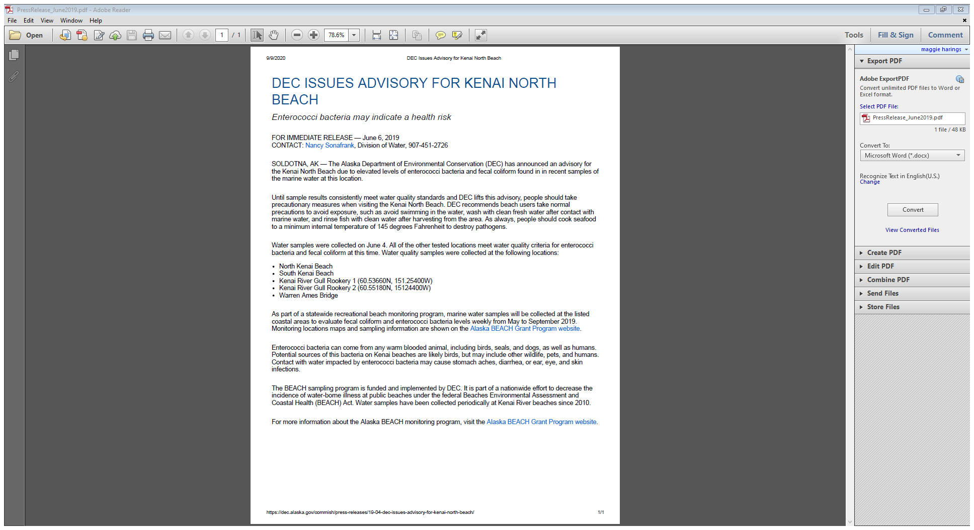

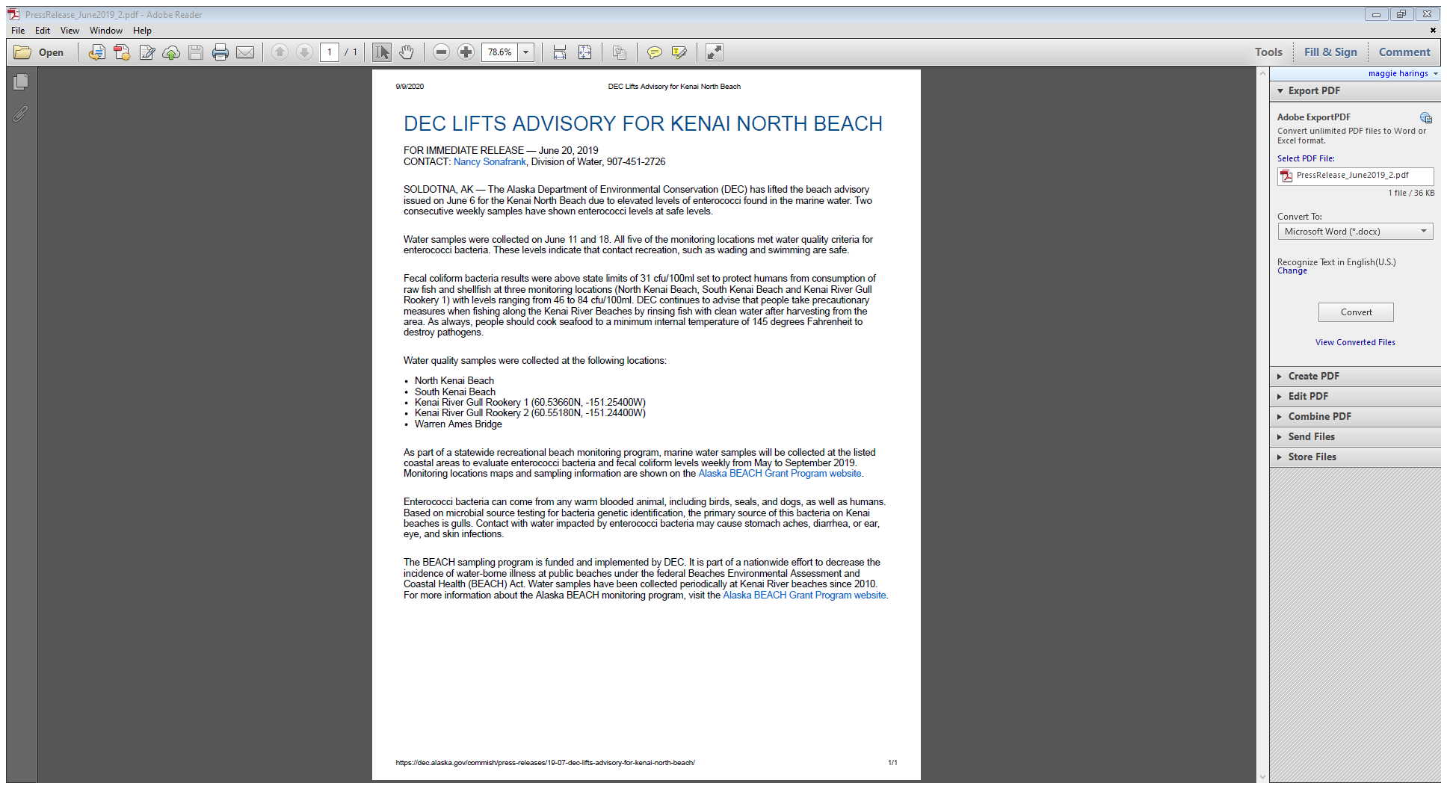

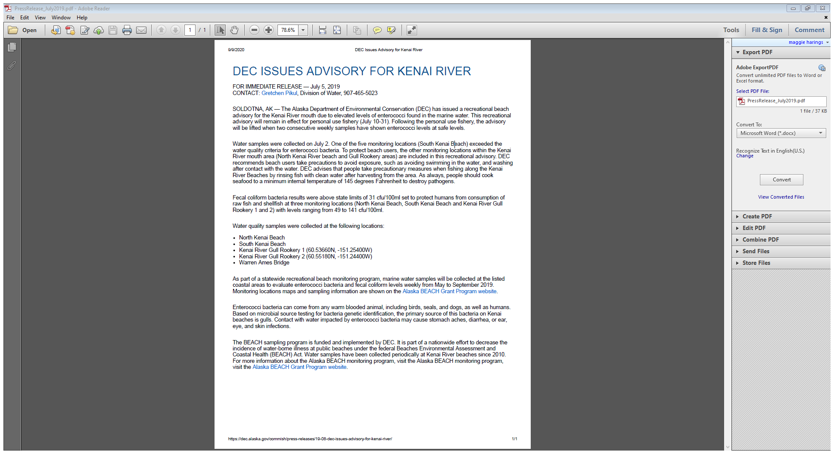

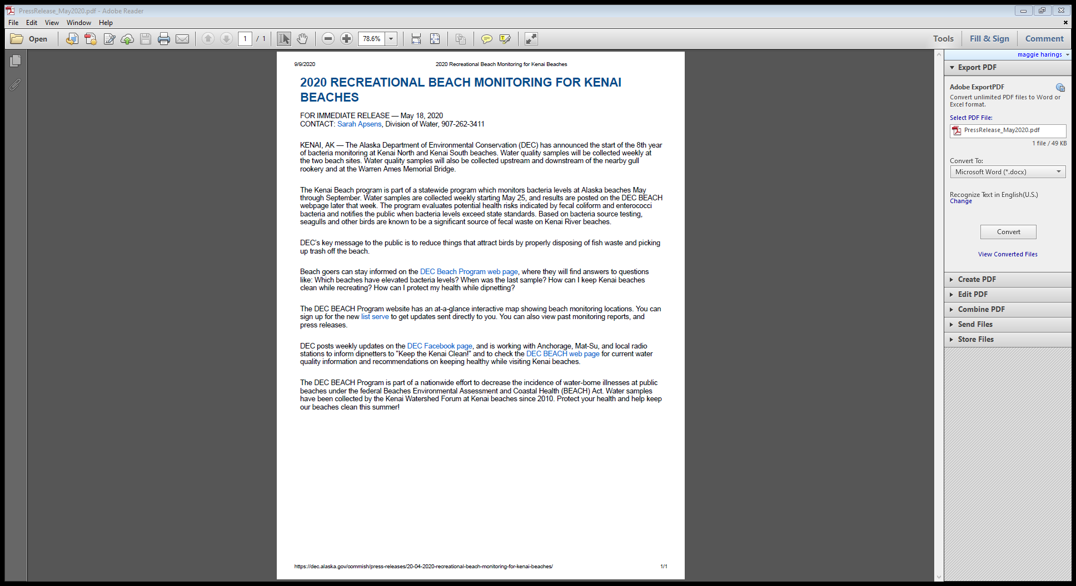

## **Appendix C: Chain-of-Custody**



## **Appendix D: EPA Marine Beach Sanitary Survey**

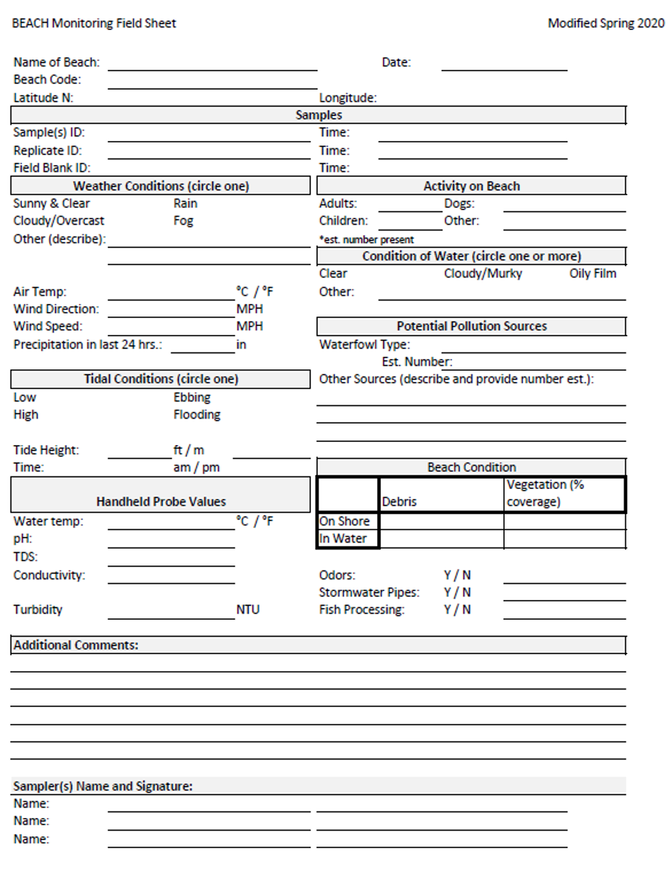

### **Appendix E: Samples Values and Exceedances (Page 1 of 9)**

|  |  |  |  |  |  |  |
| --- | --- | --- | --- | --- | --- | --- |
| **Location** | **Bacteria** | **Date** | **30 Day Geometric Mean Value** | **Individual Sample Value** | **30 Day Geometric Mean Exceedance** | **10% of Individual Samples in Prior 30 Days Exceedance** |
| Kenai River Gull Rookery 1 | Fecal Coliform | 5/21/2019 |  | 5 |  |  |
| 5/29/2019 |  | 5 |  |  |
| 6/4/2019 |  | 8 |  |  |
| 6/11/2019 |  | 46 |  |  |
| 6/18/2019 |  | 25 |  |  |
| 6/25/2019 | 12.6 | 7 |  | **> 31** |
| 7/2/2019 | 19.9 | 49 | **> 14** | **> 31** |
| 7/9/2019 | 28.7 | 49 | **> 14** | **> 31** |
| 7/17/2019 | 23.2 | 16 | **> 14** | **> 31** |
| 7/23/2019 | 16.5 | 4.5 | **> 14** | **> 31** |
| 8/1/2019 | 10.9 | 4 |  | **> 31** |
| 8/6/2019 | 15.6 | 65 | **> 14** | **> 31** |
| 8/20/2019 | 10.9 | 12 |  | **> 31** |
| 9/4/2019 | 56 | 225 | **> 14** | **> 31** |
| 5/26/2020 |  | 1 |  |  |
| 6/4/2020 |  | 12 |  |  |
| 6/9/2020 |  | 9.3 |  |  |
| 6/18/2020 |  | 38 |  |  |
| 6/23/2020 |  | 62 |  |  |
| 6/29/2020 | 38.2 | 310 | **> 14** | **> 31** |
| 7/7/2020 | 56.4 | 84 | **> 14** | **> 31** |
| 7/13/2020 | 63.6 | 17 | **> 14** | **> 31** |
| 7/20/2020 | 94.9 | 280 | **> 14** | **> 31** |
| 7/27/2020 | 91.6 | 52 | **> 14** | **> 31** |
| 8/5/2020 | 65.3 | 57 | **> 14** | **> 31** |
| 8/11/2020 | 33.5 | 3 | **> 14** | **> 31** |
| 8/18/2020 | 45.2 | 76 | **> 14** | **> 31** |
| Kenai River Gull Rookery 2 | Fecal Coliform | 5/21/2019 |  | 1 |  |  |
| 5/29/2019 |  | 10 |  |  |
| 6/4/2019 |  | 5 |  |  |
| 6/11/2019 |  | 4 |  |  |
| 6/18/2019 |  | 29 |  |  |
| 6/25/2019 | 10.8 | 25 |  |  |
|  | | | | | | |
| **30 Day Geometric Mean Fecal Coliform Concentration >14 CFU/mL** | | | | | | |
| **10% of Fecal Coliform Samples in Prior 30 Days >31 CFU/mL** | | | | | | |
| **10% of Fecal Coliform Samples in Prior 30 Days >400 CFU/mL** | | | | | | |

**Appendix E: Samples Values and Exceedances (Page 2 of 9)**

|  |  |  |  |  |  |  |
| --- | --- | --- | --- | --- | --- | --- |
| **Location** | **Bacteria** | **Date** | **30 Day Geometric Mean Value** | **Individual Sample Value** | **30 Day Geometric Mean Exceedance** | **10% of Individual Samples in Prior 30 Days Exceedance** |
| Kenai River Gull Rookery 2 | Fecal Coliform | 7/2/2019 | 16.2 | 78 | **> 14** | **> 31** |
| 7/9/2019 | 25.2 | 45 | **> 14** | **> 31** |
| 7/17/2019 | 45.9 | 80 | **> 14** | **> 31** |
| 7/23/2019 | 52.3 | 56 | **> 14** | **> 31** |
| 8/1/2019 | 53.6 | 41 | **> 14** | **> 31** |
| 8/6/2019 | 27.8 | 2 | **> 14** | **> 31** |
| 8/20/2019 | 24.1 | 74 | **> 14** | **> 31** |
| 9/4/2019 | 6.7 | 2 |  | **> 31** |
| 5/26/2020 |  | 0.5 |  |  |
| 6/4/2020 |  | 9.3 |  |  |
| 6/9/2020 |  | 12 |  |  |
| 6/18/2020 |  | 31 |  |  |
| 6/23/2020 |  | 28 |  |  |
| 6/29/2020 | 12.6 | 3.3 |  | **> 31** |
| 7/7/2020 | 17.7 | 50 | **> 14** | **> 31** |
| 7/13/2020 | 18.5 | 15 | **> 14** | **> 31** |
| 7/20/2020 | 19.4 | 40 | **> 14** | **> 31** |
| 7/27/2020 | 15.8 | 10 | **> 14** | **> 31** |
| 8/5/2020 | 24.4 | 29 | **> 14** | **> 31** |
| 8/11/2020 | 20.1 | 19 | **> 14** | **> 31** |
| 8/18/2020 | 22.6 | 27 | **> 14** | **> 31** |
| North Kenai Beach 4 | Fecal Coliform | 5/21/2019 |  | 1 |  |  |
| 5/29/2019 |  | 35 |  |  |
| 6/4/2019 |  | 102 |  |  |
| 6/11/2019 |  | 2 |  |  |
| 6/18/2019 |  | 41 |  |  |
| 6/25/2019 | 27.1 | 50 | **> 14** | **> 31** |
| 7/2/2019 | 29.9 | 57 | **> 14** | **> 31** |
| 7/9/2019 | 17.5 | 7 | **> 14** | **> 31** |
| 7/17/2019 | 49 | 346 | **> 14** | **> 31** |
| 7/23/2019 | 56.4 | 83 | **> 14** | **> 31** |
| 8/1/2019 | 75.1 | 158 | **> 14** | **> 31** |
| 8/6/2019 | 36.4 | 2 | **> 14** | **> 31** |
| 8/20/2019 | 31.8 | 39 | **> 14** | **> 31** |
|  | | | | | | |
| **30 Day Geometric Mean Fecal Coliform Concentration >14 CFU/mL** | | | | | | |
| **10% of Fecal Coliform Samples in Prior 30 Days >31 CFU/mL** | | | | | | |
| **10% of Fecal Coliform Samples in Prior 30 Days >400 CFU/mL** | | | | | | |

**Appendix E: Samples Values and Exceedances (Page 3 of 9)**

|  |  |  |  |  |  |  |
| --- | --- | --- | --- | --- | --- | --- |
| **Location** | **Bacteria** | **Date** | **30 Day Geometric Mean Value** | **Individual Sample Value** | **30 Day Geometric Mean Exceedance** | **10% of Individual Samples in Prior 30 Days Exceedance** |
| North Kenai Beach 4 | Fecal Coliform | 9/4/2019 | 5.4 | 2 |  | **> 31** |
| 5/26/2020 |  | 2 |  |  |
| 6/4/2020 |  | 36 |  |  |
| 6/9/2020 |  | 7.7 |  |  |
| 6/18/2020 |  | 54 |  |  |
| 6/23/2020 |  | 14 |  |  |
| 6/29/2020 | 14.3 | 2.9 | **> 14** | **> 31** |
| 7/7/2020 | 8.9 | 3.3 |  | **> 31** |
| 7/13/2020 | 11.6 | 29 |  | **> 31** |
| 7/20/2020 | 10.4 | 31 |  | **> 31** |
| 7/27/2020 | 7 | 2 |  | **> 31** |
| 8/5/2020 | 11.3 | 31 |  | **> 31** |
| 8/11/2020 | 18.9 | 43 | **> 14** | **> 31** |
| 8/18/2020 | 20.3 | 42 | **> 14** | **> 31** |
| South Kenai Beach 3 | Fecal Coliform | 5/21/2019 |  | 8 |  |  |
| 5/29/2019 |  | 25 |  |  |
| 6/4/2019 |  | 9 |  |  |
| 6/11/2019 |  | 5 |  |  |
| 6/18/2019 |  | 84 |  |  |
| 6/25/2019 | 19 | 26 | **> 14** | **> 31** |
| 7/2/2019 | 24.7 | 93 | **> 14** | **> 31** |
| 7/9/2019 | 39.1 | 90 | **> 14** | **> 31** |
| 7/17/2019 | 93.9 | 400 | **> 14** | **> 400** |
| 7/23/2019 | 93 | 80 | **> 14** | **> 400** |
| 8/1/2019 | 182.1 | 382 | **> 14** | **> 400** |
| 8/6/2019 | 94.9 | 7 | **> 14** | **> 400** |
| 8/20/2019 | 63.5 | 76 | **> 14** | **> 31** |
| 9/4/2019 | 12.9 | 4 |  | **> 31** |
| 5/26/2020 |  | 4 |  |  |
| 6/4/2020 |  | 69 |  |  |
| 6/9/2020 |  | 3.845 |  |  |
| 6/9/2020 |  | 7.7 |  |  |
| 6/18/2020 |  | 46 |  |  |
|  | | | | | | |
| **30 Day Geometric Mean Fecal Coliform Concentration >14 CFU/mL** | | | | | | |
| **10% of Fecal Coliform Samples in Prior 30 Days >31 CFU/mL** | | | | | | |
| **10% of Fecal Coliform Samples in Prior 30 Days >400 CFU/mL** | | | | | | |

**Appendix E: Samples Values and Exceedances (Page 4 of 9)**

|  |  |  |  |  |  |  |
| --- | --- | --- | --- | --- | --- | --- |
| **Location** | **Bacteria** | **Date** | **30 Day Geometric Mean Value** | **Individual Sample Value** | **30 Day Geometric Mean Exceedance** | **10% of Individual Samples in Prior 30 Days Exceedance** |
| South Kenai Beach 3 | Fecal Coliform | 6/23/2020 |  | 49 |  |  |
| 6/29/2020 | 17.2 | 5.7 | **> 14** | **> 31** |
| 7/7/2020 | 13.1 | 13 |  | **> 31** |
| 7/13/2020 | 39.8 | 600 | **> 14** | **> 400** |
| 7/20/2020 | 53.2 | 196 | **> 14** | **> 400** |
| 7/27/2020 | 37.6 | 8.6 | **> 14** | **> 400** |
| 8/5/2020 | 75.3 | 184 | **> 14** | **> 400** |
| 8/11/2020 | 79.4 | 17 | **> 14** | **> 400** |
| 8/18/2020 | 60.4 | 153 | **> 14** | **> 31** |
| Warren Ames Bridge | Fecal Coliform | 5/29/2019 |  | 7 |  |  |
|  |  | 6/4/2019 |  | 10 |  |  |
|  |  | 6/11/2019 |  | 11 |  |  |
|  |  | 6/18/2019 |  | 17 |  |  |
|  |  | 6/25/2019 |  | 24 |  |  |
|  |  | 7/2/2019 | 10.6 | 3 |  |  |
|  |  | 7/9/2019 | 11 | 12 |  |  |
|  |  | 7/17/2019 | 15.6 | 62 | **> 14** | **> 31** |
|  |  | 7/23/2019 | 18.6 | 42 | **> 14** | **> 31** |
|  |  | 8/1/2019 | 34.8 | 47 | **> 14** | **> 31** |
|  |  | 8/6/2019 | 27.6 | 11 | **> 14** | **> 31** |
| Warren Ames Bridge | Fecal Coliform | 8/20/2019 | 19.7 | 7 | **> 14** | **> 31** |
|  |  | 9/4/2019 | 7.3 | 5 |  |  |
|  |  | 5/26/2020 |  | 3 |  |  |
|  |  | 6/4/2020 |  | 38 |  |  |
|  |  | 6/9/2020 |  | 32 |  |  |
|  |  | 6/18/2020 |  | 15 |  |  |
|  |  | 6/23/2020 |  | 17 |  |  |
|  |  | 6/29/2020 | 15.9 | 3.3 | **> 14** | **> 31** |
|  |  | 7/7/2020 | 14.3 | 22 | **> 14** | **> 31** |
|  |  | 7/13/2020 | 12.3 | 15 |  |  |
|  |  | 7/20/2020 | 15.3 | 46 | **> 14** | **> 31** |
|  |  | 7/27/2020 | 8.7 | 1 |  | **> 31** |
|  | | | | | | |
| **30 Day Geometric Mean Fecal Coliform Concentration >14 CFU/mL** | | | | | | |
| **10% of Fecal Coliform Samples in Prior 30 Days >31 CFU/mL** | | | | | | |
| **10% of Fecal Coliform Samples in Prior 30 Days >400 CFU/mL** | | | | | | |

**Appendix E: Samples Values and Exceedances (Page 5 of 9)**

|  |  |  |  |  |  |  |
| --- | --- | --- | --- | --- | --- | --- |
| **Location** | **Bacteria** | **Date** | **30 Day Geometric Mean Value** | **Individual Sample Value** | **30 Day Geometric Mean Exceedance** | **10% of Individual Samples in Prior 30 Days Exceedance** |
| Warren Ames Bridge | Fecal Coliform | 8/5/2020 | 10 | 6.7 |  | **> 31** |
| 8/11/2020 | 6 | 1.7 |  | **> 31** |
| 8/18/2020 | 7.2 | 36 |  | **> 31** |
|  | | | | | | |
| **30 Day Geometric Mean Fecal Coliform Concentration >14 CFU/mL** | | | | | | |
| **10% of Fecal Coliform Samples in Prior 30 Days >31 CFU/mL** | | | | | | |
| **10% of Fecal Coliform Samples in Prior 30 Days >400 CFU/mL** | | | | | | |

**Appendix E: Samples Values and Exceedances (Page 6 of 9)**

|  |  |  |  |  |  |  |
| --- | --- | --- | --- | --- | --- | --- |
| **Location** | **Bacteria** | **Date** | **30 Day Geometric Mean Value** | **Individual Sample Value** | **30 Day Geometric Mean Exceedance** | **10% of Individual Samples in Prior 30 Days Exceedance** |
| Kenai River Gull Rookery 1 | Enterococci | 6/4/2019 |  | 6 |  |  |
| 6/11/2019 |  | 20 |  |  |
| 6/18/2019 |  | 23 |  |  |
| 7/2/2019 |  | 34 |  |  |
| 7/9/2019 | 21.2 | 13 |  |  |
| 7/17/2019 | 10 | 1 |  |  |
| 7/23/2019 | 5.5 | 2 |  |  |
| 8/1/2019 | 3.4 | 5 |  |  |
| 8/6/2019 | 4.2 | 10 |  |  |
| 8/20/2019 | 4.9 | 6 |  |  |
| 9/4/2019 | 16.4 | 73 |  |  |
| 5/26/2020 |  | 0.5 |  |  |
| 6/4/2020 |  | 10 |  |  |
| 6/9/2020 |  | 3 |  |  |
| 6/18/2020 |  | 4 |  |  |
| 6/23/2020 |  | 13 |  |  |
| 6/29/2020 | 7.6 | 16 |  |  |
| 7/7/2020 | 8.5 | 18 |  |  |
| 7/13/2020 | 6.8 | 1 |  |  |
| 7/20/2020 | 10.4 | 32 |  |  |
| 7/27/2020 | 8.9 | 6 |  |  |
| 8/5/2020 | 8.2 | 11 |  |  |
| 8/11/2020 | 4 | 0.5 |  |  |
| 8/18/2020 | 8.3 | 37 |  |  |
| Kenai River Gull Rookery 2 | Enterococci | 5/21/2019 |  | 1 |  |  |
|  |  | 5/29/2019 |  | 2 |  |  |
|  |  | 6/11/2019 |  | 1 |  |  |
|  |  | 6/18/2019 |  | 17 |  |  |
|  |  | 6/25/2019 | 3.2 | 3 |  |  |
|  |  | 7/2/2019 | 7.1 | 50 |  |  |
|  |  | 7/9/2019 | 8.4 | 16 |  |  |
|  |  | 7/17/2019 | 14.7 | 17 |  |  |
|  |  | 7/23/2019 | 12 | 6 |  |  |
|  |  | 8/1/2019 | 14.9 | 30 |  |  |
|  | | | | | | |
| **30 Day Geometric Mean Enterococci Concentration > 35 CFU/mL** | | | | | | |
| **10% of Enterococci Samples in Prior 30 Days >130 CFU/mL** | | | | | | |

**Appendix E: Samples Values and Exceedances (Page 7 of 9)**

|  |  |  |  |  |  |  |
| --- | --- | --- | --- | --- | --- | --- |
| **Location** | **Bacteria** | **Date** | **30 Day Geometric Mean Value** | **Individual Sample Value** | **30 Day Geometric Mean Exceedance** | **10% of Individual Samples in Prior 30 Days Exceedance** |
| Kenai River Gull Rookery 2 | Enterococci | 8/6/2019 | 12 | 5 |  |  |
| 8/20/2019 | 11.9 | 22 |  |  |
| 9/4/2019 | 9.6 | 8 |  |  |
| 5/26/2020 |  | 0.5 |  |  |
| 6/4/2020 |  | 4 |  |  |
| 6/9/2020 |  | 0.5 |  |  |
| 6/18/2020 |  | 13 |  |  |
| 6/23/2020 |  | 14 |  |  |
| 6/29/2020 | 2.8 | 0.5 |  |  |
| 7/7/2020 | 4 | 22 |  |  |
| 7/13/2020 | 4 | 0.5 |  |  |
| 7/20/2020 | 4.5 | 24 |  |  |
| 7/27/2020 | 3.3 | 3 |  |  |
| 8/5/2020 | 5.8 | 8 |  |  |
| 8/11/2020 | 3.6 | 2 |  |  |
| 8/18/2020 | 8.2 | 33 |  |  |
| North Kenai Beach 4 | Enterococci | 5/21/2019 |  | 1 |  |  |
|  |  | 5/29/2019 |  | 6 |  |  |
|  |  | 6/4/2019 |  | 139 |  |  |
|  |  | 6/11/2019 |  | 1 |  |  |
|  |  | 6/18/2019 |  | 36 |  |  |
|  |  | 6/25/2019 | 13.5 | 15 |  | **> 130** |
|  |  | 7/2/2019 | 20.3 | 46 |  | **> 130** |
|  |  | 7/9/2019 | 9.4 | 3 |  |  |
|  |  | 7/17/2019 | 30.7 | 365 |  | **> 130** |
|  |  | 7/23/2019 | 35.2 | 72 | **> 35** | **> 130** |
|  |  | 8/1/2019 | 69.2 | 291 | **> 35** | **> 130** |
|  |  | 8/6/2019 | 67 | 59 | **> 35** | **> 130** |
|  |  | 8/20/2019 | 66.7 | 16 | **> 35** | **> 130** |
|  |  | 9/4/2019 | 26.6 | 20 |  |  |
|  |  | 5/26/2020 |  | 2 |  |  |
|  |  | 6/4/2020 |  | 27 |  |  |
|  |  | 6/9/2020 |  | 8 |  |  |
|  |  | 6/18/2020 |  | 13 |  |  |
|  |  | 6/23/2020 |  | 18 |  |  |
|  | | | | | | |
| **30 Day Geometric Mean Enterococci Concentration > 35 CFU/mL** | | | | | | |
| **10% of Enterococci Samples in Prior 30 Days >130 CFU/mL** | | | | | | |

**Appendix E: Samples Values and Exceedances (Page 8 of 9)**

|  |  |  |  |  |  |  |
| --- | --- | --- | --- | --- | --- | --- |
| **Location** | **Bacteria** | **Date** | **30 Day Geometric Mean Value** | **Individual Sample Value** | **30 Day Geometric Mean Exceedance** | **10% of Individual Samples in Prior 30 Days Exceedance** |
| North Kenai Beach 4 | Enterococci | 6/29/2020 | 10 | 2 |  |  |
| 7/7/2020 | 6.8 | 4 |  |  |
| 7/13/2020 | 6.2 | 5 |  |  |
| 7/20/2020 | 5.3 | 6 |  |  |
| 7/27/2020 | 2.6 | 0.5 |  |  |
| 8/5/2020 | 4.7 | 38 |  |  |
| 8/11/2020 | 5.4 | 8 |  |  |
| 8/18/2020 | 7.3 | 23 |  |  |
| South Kenai Beach 3 | Enterococci | 5/21/2019 |  | 5 |  |  |
| 5/29/2019 |  | 6 |  |  |
| 6/4/2019 |  | 2 |  |  |
| 6/11/2019 |  | 7 |  |  |
| 6/18/2019 |  | 50 |  |  |
| 6/25/2019 | 12.4 | 71 |  |  |
| 7/2/2019 | 29 | 411 |  | > 130 |
| 7/9/2019 | 47.2 | 23 | **> 35** | **> 130** |
| 7/17/2019 | 119.5 | 727 | **> 35** | **> 130** |
| 7/23/2019 | 102.3 | 23 | **> 35** | **> 130** |
| 8/1/2019 | 98.9 | 249 | **> 35** | **> 130** |
| 8/6/2019 | 108.2 | 155 | **> 35** | **> 130** |
| 8/20/2019 | 126.1 | 285 | **> 35** | **> 130** |
| 9/4/2019 | 107.3 | 28 | **> 35** | **> 130** |
| 5/26/2020 |  | 2 |  |  |
| 6/4/2020 |  | 50 |  |  |
| 6/9/2020 |  | 6 |  |  |
| 6/18/2020 |  | 38 |  |  |
| 6/23/2020 |  | 25 |  |  |
| 6/29/2020 | 25.5 | 38 |  |  |
| 7/7/2020 | 14.5 | 3 |  |  |
| 7/13/2020 | 28.6 | 178 |  | > 130 |
| 7/20/2020 | 33.8 | 87 |  | > 130 |
| 7/27/2020 | 23.4 | 4 |  | > 130 |
| 8/5/2020 | 31.9 | 178 |  | > 130 |
| 8/11/2020 | 39.7 | 9 | **> 35** | **> 130** |
|  | | | | | | |
| **30 Day Geometric Mean Enterococci Concentration > 35 CFU/mL** | | | | | | |
| **10% of Enterococci Samples in Prior 30 Days >130 CFU/mL** | | | | | | |

**Appendix E: Samples Values and Exceedances (Page 9 of 9)**

|  |  |  |  |  |  |  |
| --- | --- | --- | --- | --- | --- | --- |
| **Location** | **Bacteria** | **Date** | **30 Day Geometric Mean Value** | **Individual Sample Value** | **30 Day Geometric Mean Exceedance** | **10% of Individual Samples in Prior 30 Days Exceedance** |
| South Kenai Beach 3 | Enterococci | 8/18/2020 | 35.1 | 96 | **> 35** | **> 130** |
| Warren Ames Bridge | Enterococci | 5/21/2019 |  | 1 |  |  |
| 5/29/2019 |  | 1 |  |  |
| 6/4/2019 |  | 3 |  |  |
| 6/11/2019 |  | 1 |  |  |
| 6/18/2019 |  | 1 |  |  |
| 6/25/2019 | 1.9 | 8 |  |  |
| 7/2/2019 | 1.9 | 1 |  |  |
| 7/9/2019 | 1.7 | 2 |  |  |
| 7/17/2019 | 2.6 | 7 |  |  |
| 7/23/2019 | 3 | 2 |  |  |
| 8/1/2019 | 4.7 | 18 |  |  |
| 8/6/2019 | 4 | 2 |  |  |
| 8/20/2019 | 2.9 | 1 |  |  |
| 9/4/2019 | 2.2 | 5 |  |  |
| 5/26/2020 |  | 1 |  |  |
| 6/4/2020 |  | 6 |  |  |
| 6/9/2020 |  | 2 |  |  |
| 6/18/2020 |  | 1 |  |  |
| 6/23/2020 |  | 2 |  |  |
| 6/29/2020 | 1.9 | 1 |  |  |
| 7/7/2020 | 1.6 | 3 |  |  |
| 7/13/2020 | 1.6 | 2 |  |  |
| 7/20/2020 | 1.6 | 1 |  |  |
| 7/27/2020 | 1.2 | 0.5 |  |  |
| 8/5/2020 | 1.4 | 2 |  |  |
| 8/11/2020 | 1 | 0.5 |  |  |
| 8/18/2020 | 1.3 | 8 |  |  |
|  | | | | | | |
| **30 Day Geometric Mean Enterococci Concentration > 35 CFU/mL** | | | | | | |
| **10% of Enterococci Samples in Prior 30 Days >130 CFU/mL** | | | | | | |

## **Appendix F: Microbial Source Tracing Data**

Table 5: Microbial source tracing data from five sites sampled for bacteria concentrations in the lower Kenai River, 2019 – 2020. Values are copies of biomarker gene per 100 mL.

|  |  |  |  |  |
| --- | --- | --- | --- | --- |
| **Date** | **Location** | **Dog Feces** | **Gull Feces** | **Human Feces** |
| 6/4/2019 | Kenai River Gull Rookery 1 | ND | 3610 | DNQ |
| Kenai River Gull Rookery 2 | ND | 2140 | ND |
| North Kenai Beach 4 | 4660 | 965 | ND |
| South Kenai Beach 3 | 1210 | 1380 | ND |
| Warren Ames Bridge | ND | 1680 | DNQ |
| 8/8/2019 | Kenai River Gull Rookery 1 | ND | 3040 | 525 |
| Kenai River Gull Rookery 2 | DNQ | 9010 | DNQ |
| North Kenai Beach 4 | ND | 11600 | DNQ |
| South Kenai Beach 3 | ND | 28200 | DNQ |
| Warren Ames Bridge | DNQ | 2920 | DNQ |
| 6/23/2020 | Kenai River Gull Rookery 1 | ND | 3320 | ND |
| Kenai River Gull Rookery 2 | ND | 3300 | ND |
| North Kenai Beach 4 | ND | 688 | ND |
| South Kenai Beach 3 | ND | DNQ | ND |
| Warren Ames Bridge | DNQ | DNQ | ND |
| 7/20/2020 | Kenai River Gull Rookery 1 | ND | 8050 | DNQ |
| Kenai River Gull Rookery 2 | ND | 8550 | 629 |
| North Kenai Beach 4 | DNQ | 1590 | 1140 |
| South Kenai Beach 3 | DNQ | 13100 | 1220 |
| Warren Ames Bridge | ND | 5210 | DNQ |

*ND = Not detected*

*DNQ = Detected but not quantifiable*